|  |  |
| --- | --- |
|  | **MINISTRY OF EDUCATION AND TRAINING** |

|  |
| --- |
| **FPT UNIVERSITY** |
| Capstone Project Document |
| Gunpla World Application |
|  |
| |  |  | | --- | --- | | **Team 15** | | | **Group Members** | Hoàng Ngô Minh Tùng – Role 1 – SE62231  Nguyễn Bảo Khánh – Role 2 – SE61978  Lê Nguyễn Ngọc Sang – Role 3 – SE61647 | | **Supervisor** | Phạm Công Thành | | **Ext Supervisor** |  | | **Capstone Project code** |  | |
|  |
|  |

– TP.HCM, 09/2018 –

**D. Report No. 4 Software Design Description**

**1. Design Overview**

This document describes the technical and user interface design of **GWA System**. It includes the architectural design, the detailed design of common functions and business functions and the design of database model.

The architectural design describes the overall architecture of the system and the architecture of each main component and subsystem.

The detailed design describes static and dynamic structure for each components and functions. It includes class diagram, class explanations and sequence diagrams for each use cases.

The database design describes the relationship between entities and detail of each entity.

Document overview:

* Section 2: gives an overall description of the system architecture design.
* Section 3: gives component diagrams that describe the connection and integration of the system.
* Section 4: gives the detail design description which includes class diagram, class explanation, and sequence diagram to details the application functions.
* Section 5: describe screens design.
* Section 6: describe a fully attributed ERD.
* Section 7: describe algorithms**.**

**2. System Architectural Design**

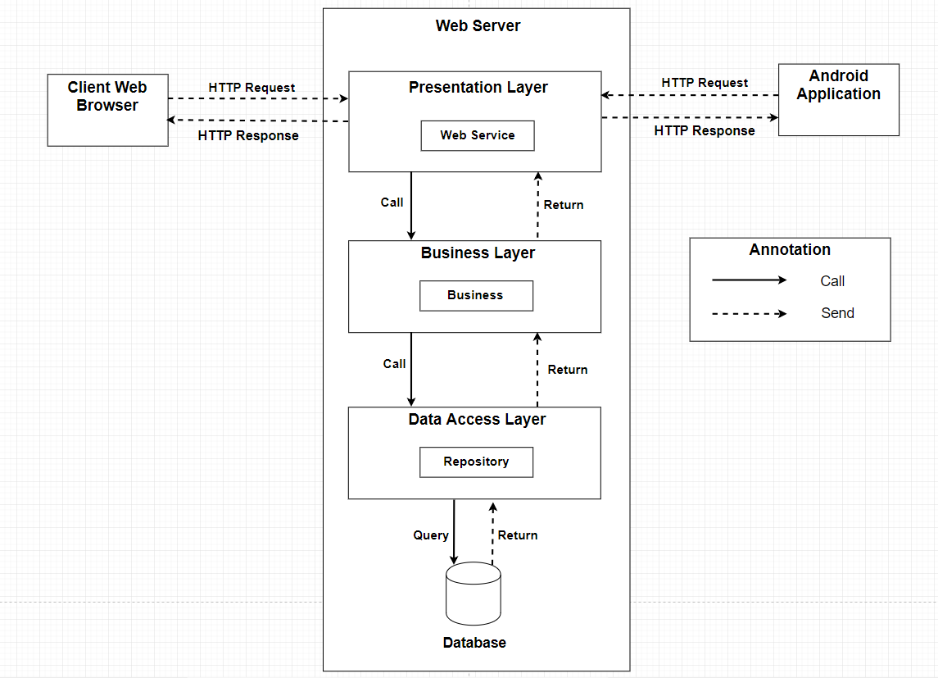

**2.1. Web application architecture description**

In Web Application, the system is developed under 3-layers architecture style, with Spring Boot technology. We choose this architecture for Web application because of the following advantages:

* We can separate our business code into logical layers, each layer performing a specific role within the application. Presentation layer is responsible for handling all user interface and browser communication logic, whereas business layer is responsible for executing business logics and data access layer is responsible for executing anythings that relate to database.
* The presentation layer provides Rest API for web and mobile app to communicate by **json** data through network environment, so we can use the business code in web service without repeating the code.
* It is easy to maintain, to apply object oriented concept and to update data provider queries.

This project follows 3-layers architecture with the following components:

* **WebController:** is the part of presentation layer that acts like event handler to handle user interaction. It receives request from user by request mapping and select the appropriate view to return to user.
* **RestController:** is the part of presentation layer that provides api for client to communicate and reads data from response, call the business layer to execute business logic, then return **json** data to client. Web and Mobile app will render that **json** data to UI.
* **Service:** is the part of business layer that is responsible for executing complex business logics. This component will get user’s data from controller, call repository and perform business operations.
* **Model:** is the part of data access layer that contains the mapping of actual tables in database to classes.
* **Repository:** is the part of data access layer that uses models to execute CRUD database operations. This component only execute operations that are related to and is meant for directly accessing the database.

**3. Component Diagram**

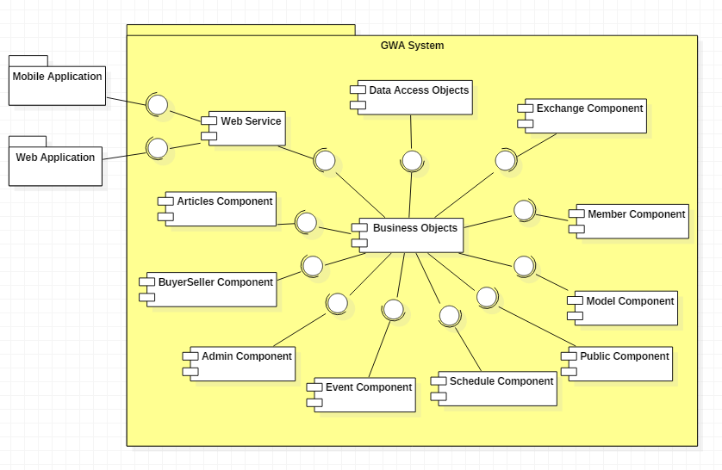

|  |  |
| --- | --- |
| Component Dictionary: Describes components | |
| Web Application | Web application package |
| Mobile Application | Mobile application package |
| Web Service | Provide API for client to interact with the system |
| Admin Component | Component to handle admin activities in the system |
| BuyerSeller Component | Component to handle buy/seller activities in the system |
| Member Component | Component to handle member activities in the system |
| Public Component | Component to handle guest activities in the system |
| Schedule Component | Component to handle scheduler in the system |
| Event Component | Component about manipulating events |
| Articles Component | Component about manipulating articles |
| Exchange Component | Component about manipulating exchange |
| Model Component | Component about manipulating models |
| Business Objects | Common objects to handle domain business operations for each components |
| Data Access Objects | Component to handle interaction between the system and database |

**4. Detailed Description**

**4.1. Class Diagram**

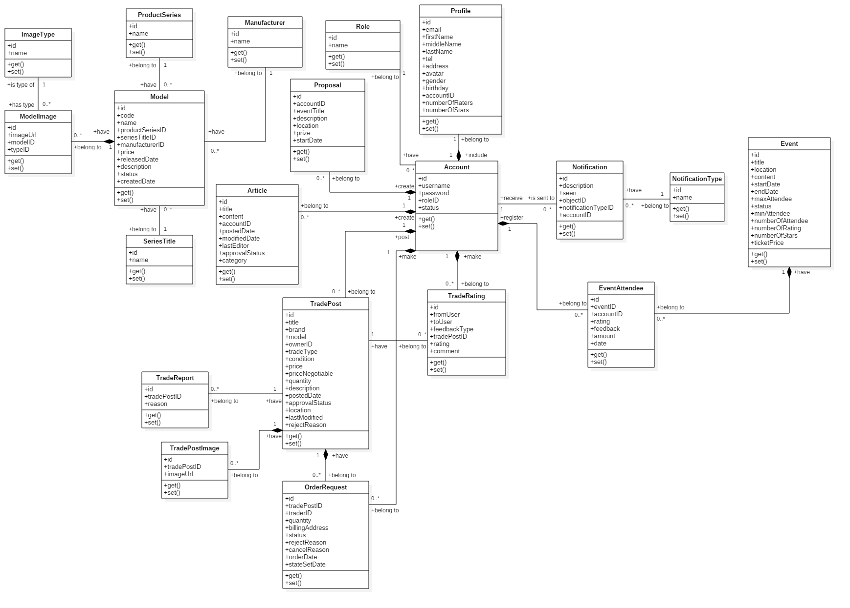

|  |  |  |
| --- | --- | --- |
| **Class Name** | **Mapping column with Conceptual diagram** | **Description** |
| Model | Model | Contain model’s information |
| ModelImage | N/A | Not exist in conceptual diagram. It’s used to contain models’s images |
| ImageType | N/A | Not exist in conceptual diagram. It’s used to contain types of images |
| ProductSeries | N/A | Not exist in conceptual diagram. It’s used to contain product series information |
| SeriesTitle | N/A | Not exist in conceptual diagram. It’s used to contain series title information |
| Manufacturer | N/A | Not exist in conceptual diagram. It’s used to contain manufacturers information |
| Article | Articles | Contain article’s information |
| Proposal | Proposal | Contain member’s proposal information |
| Account | User | Contain user’s information for authentication and authorization |
| Profile | N/A | Not exist in conceptual diagram. It’s used to contain user’s profile information |
| Role | N/A | Not exist in conceptual diagram. It’s used to contain user’s role information |
| TradePost | Trade | Contain buyer/seller’s trade post information |
| TradePostImage | N/A | Not exist in conceptual diagram. It’s used to contain trade post’s images |
| OrderRequest | Order | Contain information of user’s order request to trade |
| TradeRating | Evaluate | Contain trade rating information |
| TradeReport | N/A | Not exist in conceptual diagram. It’s used to contain user’s report on trade post |
| Event | Event | Contain event information |
| EventAttendee | EventRegist | Contain user’s registration on events |
| Notification | Notification | Contain notification information |
| NotificationType | N/A | Not exist in conceptual diagram. It’s used to contain notification type information |

**4.2. Class Diagram Explanation**

**4.2.1. Model**

**Attribute**

|  |  |  |  |
| --- | --- | --- | --- |
| **Attribute** | **Type** | **Visibility** | **Description** |
| id | int | Private | Unique identifier of model |
| name | String | Private | Model name |
| productSeries | ProductSeries | Private | Model’s product series |
| seriesTitle | SeriesTitle | Private | Model’s series title |
| manufacturer | Manufacturer | Private | Model’s manufacturer |
| price | float | Private | Model’s price |
| realeasedDate | String | Private | Model’s released date |
| description | String | Private | Model’s description |
| status | String | Private | Model’s status |
| createdDate | String | Private | Model’s created date |

**Method**

|  |  |  |  |
| --- | --- | --- | --- |
| **Method** | **Return Type** | **Visibility** | **Description** |
| getter | Attribute type | Public | Get attribute value |
| setter | Void | Public | Set value of attribute |

**4.2.2. SeriesTitle**

**Attribute**

|  |  |  |  |
| --- | --- | --- | --- |
| **Attribute** | **Type** | **Visibility** | **Description** |
| id | int | Private | Unique identifier of series title |
| name | String | Private | Series title’s name |

**Method**

|  |  |  |  |
| --- | --- | --- | --- |
| **Method** | **Return Type** | **Visibility** | **Description** |
| getter | Attribute type | Public | Get attribute value |
| setter | Void | Public | Set value of attribute |

**4.2.3. ProductSeries**

**Attribute**

|  |  |  |  |
| --- | --- | --- | --- |
| **Attribute** | **Type** | **Visibility** | **Description** |
| id | int | Private | Unique identifier of product series |
| name | String | Private | Product series’s name |

**Method**

|  |  |  |  |
| --- | --- | --- | --- |
| **Method** | **Return Type** | **Visibility** | **Description** |
| getter | Attribute type | Public | Get attribute value |
| setter | Void | Public | Set value of attribute |

**4.2.4. Manufacturer**

**Attribute**

|  |  |  |  |
| --- | --- | --- | --- |
| **Attribute** | **Type** | **Visibility** | **Description** |
| id | int | Private | Unique identifier of manufacturer |
| name | String | Private | Manufacturer’s name |

**Method**

|  |  |  |  |
| --- | --- | --- | --- |
| **Method** | **Return Type** | **Visibility** | **Description** |
| getter | Attribute type | Public | Get attribute value |
| setter | Void | Public | Set value of attribute |

**4.2.5. ModelImage**

**Attribute**

|  |  |  |  |
| --- | --- | --- | --- |
| **Attribute** | **Type** | **Visibility** | **Description** |
| id | int | Private | Unique identifier of model image |
| imageUrl | String | Private | Image’s url |
| model | Model | Private | The model which image belongs to |
| type | ImageType | Private | Image’s type |

**Method**

|  |  |  |  |
| --- | --- | --- | --- |
| **Method** | **Return Type** | **Visibility** | **Description** |
| getter | Attribute type | Public | Get attribute value |
| setter | Void | Public | Set value of attribute |

**4.2.6. ImageType**

**Attribute**

|  |  |  |  |
| --- | --- | --- | --- |
| **Attribute** | **Type** | **Visibility** | **Description** |
| id | int | Private | Unique identifier of image type |
| name | String | Private | Image type’s name |

**Method**

|  |  |  |  |
| --- | --- | --- | --- |
| **Method** | **Return Type** | **Visibility** | **Description** |
| getter | Attribute type | Public | Get attribute value |
| setter | Void | Public | Set value of attribute |

**4.2.7. Article**

**Attribute**

|  |  |  |  |
| --- | --- | --- | --- |
| **Attribute** | **Type** | **Visibility** | **Description** |
| id | int | Private | Unique identifier of article |
| title | String | Private | Article title |
| content | String | Private | Article content detail information |
| account | Account | Private | User who posts article |
| postedDate | String | Private | Article posted date |
| modifiedDate | String | Private | Article last modified date |
| lastEditor | String | Private | Username of the last editor |
| approvalStatus | String | Private | Article’s approval status |
| category | String | Private | Article’s category |

**Method**

|  |  |  |  |
| --- | --- | --- | --- |
| **Method** | **Return Type** | **Visibility** | **Description** |
| getter | Attribute type | Public | Get attribute value |
| setter | Void | Public | Set value of attribute |

**4.2.8. Proposal**

**Attribute**

|  |  |  |  |
| --- | --- | --- | --- |
| **Attribute** | **Type** | **Visibility** | **Description** |
| id | int | Private | Unique identifier of proposal |
| account | Account | Private | User who posts proposal |
| eventTitle | String | Private | Proposal event title |
| description | String | Private | Proposal description |
| location | String | Private | Proposal event location |
| prize | String | Private | Proposal event winng rewards |
| startDate | String | Private | Proposal event start date |

**Method**

|  |  |  |  |
| --- | --- | --- | --- |
| **Method** | **Return Type** | **Visibility** | **Description** |
| getter | Attribute type | Public | Get attribute value |
| setter | Void | Public | Set value of attribute |

**4.2.9. Account**

**Attribute**

|  |  |  |  |
| --- | --- | --- | --- |
| **Attribute** | **Type** | **Visibility** | **Description** |
| id | int | Private | Unique identifier of account |
| username | String | Private | Account username |
| password | String | Private | Account password |
| role | Role | Private | Account role |
| status | String | Private | Account status |

**Method**

|  |  |  |  |
| --- | --- | --- | --- |
| **Method** | **Return Type** | **Visibility** | **Description** |
| getter | Attribute type | Public | Get attribute value |
| setter | Void | Public | Set value of attribute |

**4.2.10. Role**

**Attribute**

|  |  |  |  |
| --- | --- | --- | --- |
| **Attribute** | **Type** | **Visibility** | **Description** |
| id | int | Private | Unique identifier of role |
| name | String | Private | Role name |

**Method**

|  |  |  |  |
| --- | --- | --- | --- |
| **Method** | **Return Type** | **Visibility** | **Description** |
| getter | Attribute type | Public | Get attribute value |
| setter | Void | Public | Set value of attribute |

**4.2.11. Profile**

**Attribute**

|  |  |  |  |
| --- | --- | --- | --- |
| **Attribute** | **Type** | **Visibility** | **Description** |
| id | int | Private | Unique identifier of user profile |
| email | String | Private | User’s email |
| firstName | String | Private | User’s first name |
| middleName | String | Private | User’s middle name |
| lastName | String | Private | User’s last name |
| tel | String | Private | User’s mobile number |
| address | String | Private | User’s address |
| avatar | String | Private | User’s avatar as image |
| gender | String | Private | User’s gender |
| birthday | String | Private | User’s birthday |
| account | Account | Private | Profile owner |

**Method**

|  |  |  |  |
| --- | --- | --- | --- |
| **Method** | **Return Type** | **Visibility** | **Description** |
| getter | Attribute type | Public | Get attribute value |
| setter | Void | Public | Set value of attribute |

**4.2.12. Event**

**Attribute**

|  |  |  |  |
| --- | --- | --- | --- |
| **Attribute** | **Type** | **Visibility** | **Description** |
| id | int | Private | Unique identifier of event |
| title | String | Private | Event title |
| location | String | Private | Event location occur |
| content | String | Private | Event content |
| startDate | String | Private | Event start date |
| endDate | String | Private | Event end date |
| maxAttendee | int | Private | Event’s maximum attendee |
| status | String | Private | Event status |
| minAttendee | int | Private | Event’s minimum attendee |
| numberOfAttendee | int | Private | Event’s current number of attendee, this attribute is for improving performance |
| numberOfRating | int | Private | Number of users who evaluate the events, this attribute is for improving performance in calculating event rating |
| numberOfStars | int | Private | Number of star rating, this attribute is for improving performance in calculating event rating |
| ticketPrice | float | Private | Price of event’s ticket |

**Method**

|  |  |  |  |
| --- | --- | --- | --- |
| **Method** | **Return Type** | **Visibility** | **Description** |
| getter | Attribute type | Public | Get attribute value |
| setter | Void | Public | Set value of attribute |

**4.2.13. EventAttendee**

**Attribute**

|  |  |  |  |
| --- | --- | --- | --- |
| **Attribute** | **Type** | **Visibility** | **Description** |
| id | int | Private | Unique identifier of eventattendee |
| event | Event | Private | Object event |
| account | Account | Private | Object account which represents the event attendee |
| rating | int | Private | User’s rating on events |
| feedback | String | Private | User’s feedback on events |
| amount | int | Private | Number of tickets which a user regist for |
| date | String | Private | Event registration date |

**Method**

|  |  |  |  |
| --- | --- | --- | --- |
| **Method** | **Return Type** | **Visibility** | **Description** |
| getter | Attribute type | Public | Get attribute value |
| setter | Void | Public | Set value of attribute |

**4.2.14. Notification**

**Attribute**

|  |  |  |  |
| --- | --- | --- | --- |
| **Attribute** | **Type** | **Visibility** | **Description** |
| id | int | Private | Unique identifier of notification |
| description | String | Private | Notification description |
| seen | int | Private | Notification seen status |
| object | object | Private | Notification object message |
| notificationType | NoticationType | Private | Notification type object |
| account | Account | Private | User whom notification is sent to |

**Method**

|  |  |  |  |
| --- | --- | --- | --- |
| **Method** | **Return Type** | **Visibility** | **Description** |
| getter | Attribute type | Public | Get attribute value |
| setter | Void | Public | Set value of attribute |

**4.2.15. NotificationType**

**Attribute**

|  |  |  |  |
| --- | --- | --- | --- |
| **Attribute** | **Type** | **Visibility** | **Description** |
| id | int | Private | Unique identifier of notificationtype |
| name | String | Private | NotificationType name |

**Method**

|  |  |  |  |
| --- | --- | --- | --- |
| **Method** | **Return Type** | **Visibility** | **Description** |
| getter | Attribute type | Public | Get attribute value |
| setter | Void | Public | Set value of attribute |

**4.2.16. TradePost**

**Attribute**

|  |  |  |  |
| --- | --- | --- | --- |
| **Attribute** | **Type** | **Visibility** | **Description** |
| id | int | Private | Unique identifier of trade post |
| title | String | Private | Trade post title |
| brand | String | Private | Product’s brand |
| model | String | Private | Product name |
| owner | Account | Private | Trade post owner |
| tradeType | String | Private | Trade type |
| condition | String | Private | Trade condition |
| price | float | Private | Products’s price |
| priceNegotiable | float | Private | Price may be negotiable when exchange |
| quantity | int | Private | Product quantity |
| description | String | Private | Trade post description |
| postedDate | String | Private | Trade posted date |
| approvalStatus | String | Private | Trade’s approval status |
| location | String | Private | Location for exchange |
| lastModified | String | Private | Trade post’s last modified |
| rejectReason | String | Private | Reject reason from administrator |

**Method**

|  |  |  |  |
| --- | --- | --- | --- |
| **Method** | **Return Type** | **Visibility** | **Description** |
| getter | Attribute type | Public | Get attribute value |
| setter | Void | Public | Set value of attribute |

**4.2.17. OrderRequest**

**Attribute**

|  |  |  |  |
| --- | --- | --- | --- |
| **Attribute** | **Type** | **Visibility** | **Description** |
| id | int | Private | Unique identifier of order request |
| tradePost | TradePost | Private | Trade post that user request to order |
| trader | Account | Private | Member who sends order request to buyer/seller for exchange |
| quantity | int | Private | Number of order products |
| billingAddress | String | Private | Negotiable exchange location |
| statusID | int | Private | Order request status |
| rejectReason | String | Private | Reason that buyer/seller reject the exchange after accepted order request |
| cancelReason | String | Private | Reason that buyer/seller cancel order request |
| orderDate | String | Private | Order request date |
| stateSetDate | String | Private | The datetime which the order request is reject or canceled |

**Method**

|  |  |  |  |
| --- | --- | --- | --- |
| **Method** | **Return Type** | **Visibility** | **Description** |
| getter | Attribute type | Public | Get attribute value |
| setter | Void | Public | Set value of attribute |

**4.2.18. TradePostImage**

**Attribute**

|  |  |  |  |
| --- | --- | --- | --- |
| **Attribute** | **Type** | **Visibility** | **Description** |
| id | int | Private | Unique identifier of trade post image |
| tradePost | TradePost | Private | The trade post which image belongs to |
| imageUrl | String | Private | Image url |

**Method**

|  |  |  |  |
| --- | --- | --- | --- |
| **Method** | **Return Type** | **Visibility** | **Description** |
| getter | Attribute type | Public | Get attribute value |
| setter | Void | Public | Set value of attribute |

**4.2.19. TradeReport**

**Attribute**

|  |  |  |  |
| --- | --- | --- | --- |
| **Attribute** | **Type** | **Visibility** | **Description** |
| id | int | Private | Unique identifier of trade report |
| tradePost | TradePost | Private | The trade post which trade report belongs to |
| reason | String | Private | Reason of report |

**Method**

|  |  |  |  |
| --- | --- | --- | --- |
| **Method** | **Return Type** | **Visibility** | **Description** |
| getter | Attribute type | Public | Get attribute value |
| setter | Void | Public | Set value of attribute |

**4.2.20. TradeRating**

**Attribute**

|  |  |  |  |
| --- | --- | --- | --- |
| **Attribute** | **Type** | **Visibility** | **Description** |
| id | int | Private | Unique identifier of trade rating |
| fromUser | Account | Private | User who does the evaluation |
| toUser | Account | Private | User who receives the rating |
| feedbackType | String | Private | Represents for type of rating, a member evaluate the exchange for trade post owner or trade post owner evaluates the traders, for calculating the reputation |
| tradePost | TradePost | Private | Trade post that is evaluated |
| rating | int | Private | Number of stars rating |
| comment | String | Private | Feedback about exchange |

**Method**

|  |  |  |  |
| --- | --- | --- | --- |
| **Method** | **Return Type** | **Visibility** | **Description** |
| getter | Attribute type | Public | Get attribute value |
| setter | Void | Public | Set value of attribute |

**4.3. Interaction Diagram**

**4.3.1. Sequence Diagram**

**4.3.1.1. Search model**

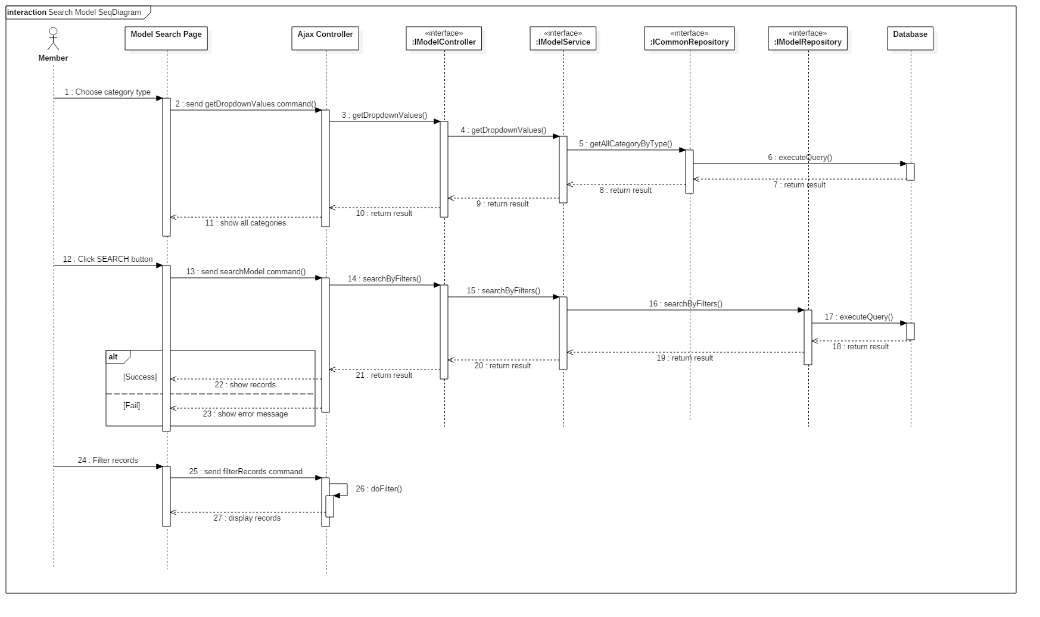

**4.3.1.2. Create model**

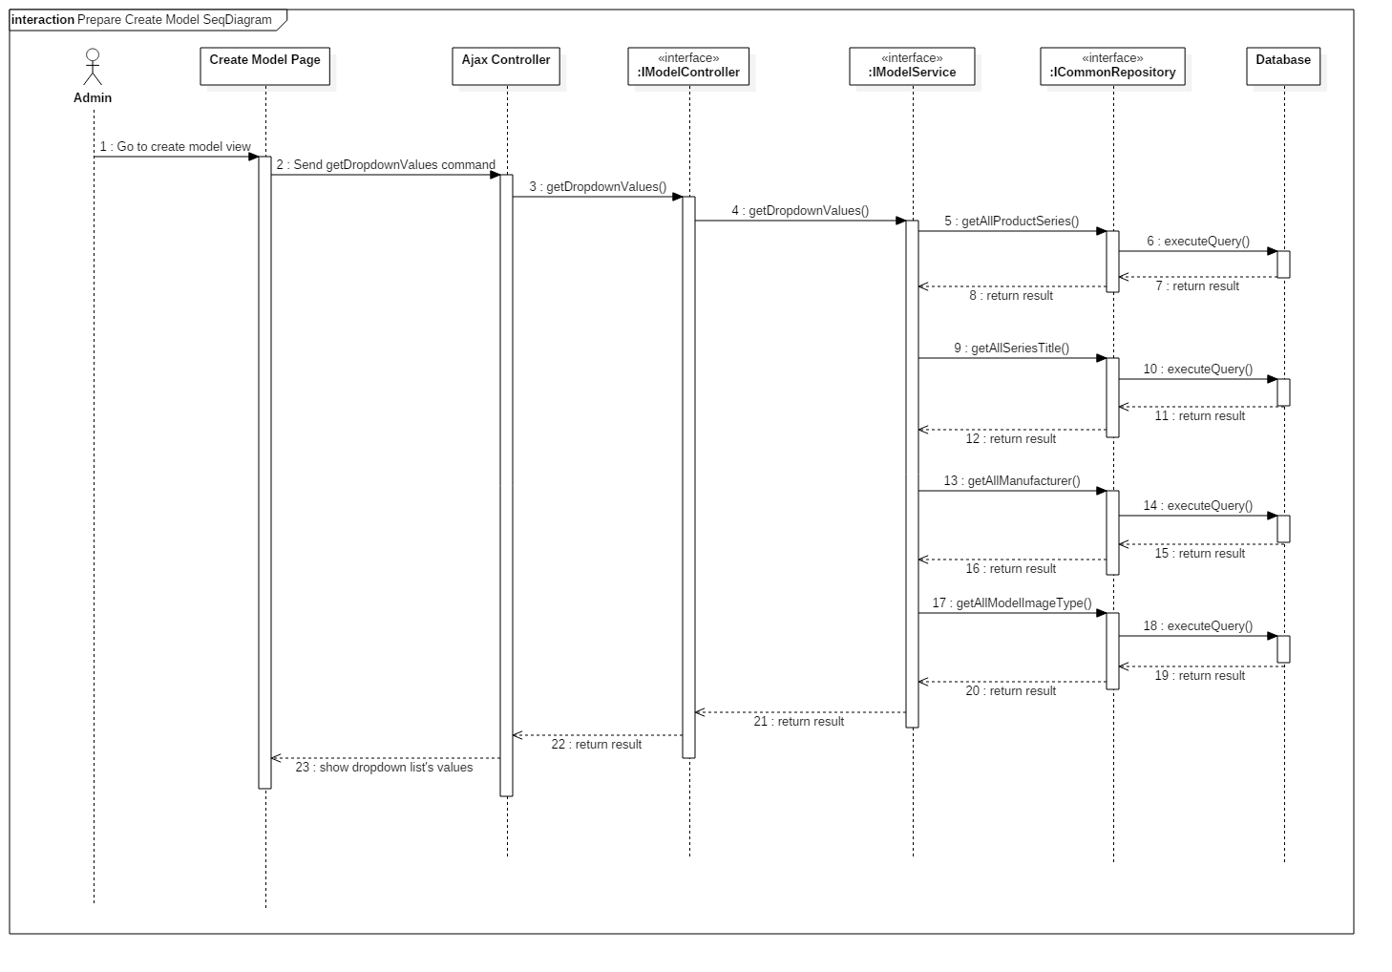 **4.3.1.2.1. Prepare Create Model**

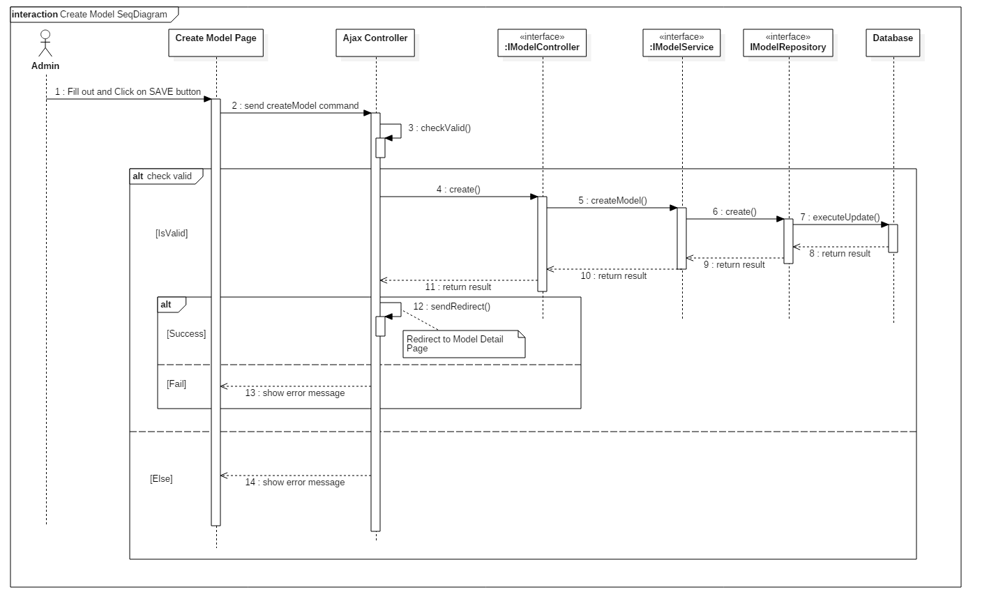 **4.3.1.2.2. Create Model**

**4.3.1.3. Edit model**

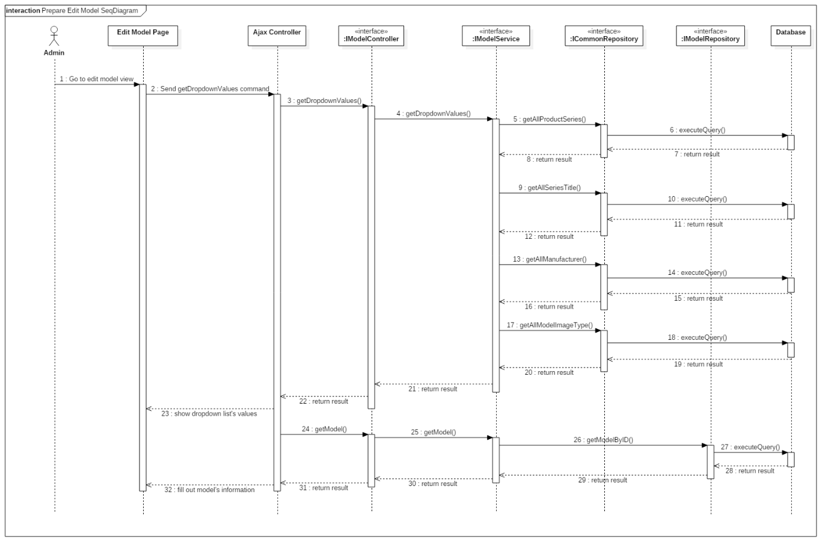 **4.3.1.3.1. Prepare Edit Model**

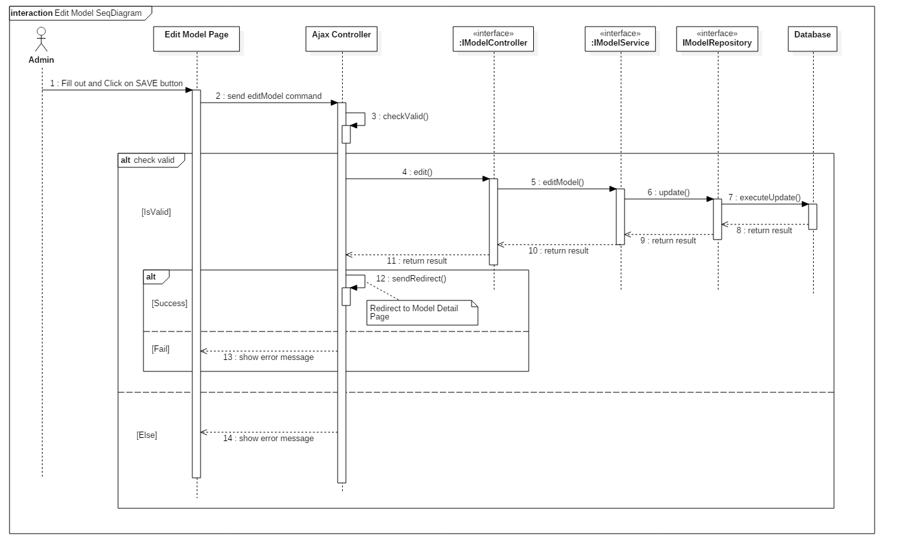 **4.3.1.3.2. Edit Model**

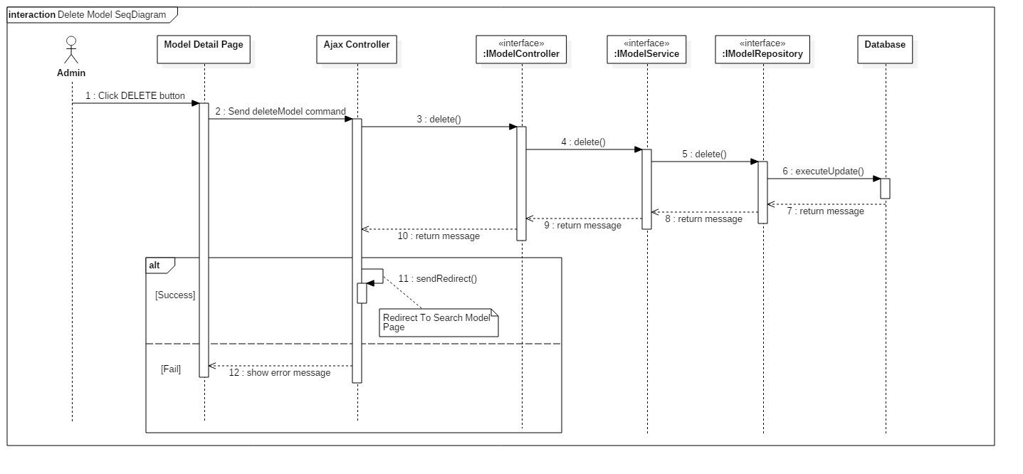 **4.3.1.4. Delete model**

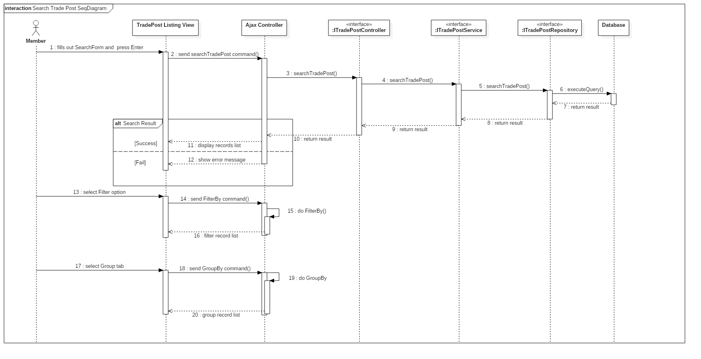 **4.3.1.5. Search Trade Post**

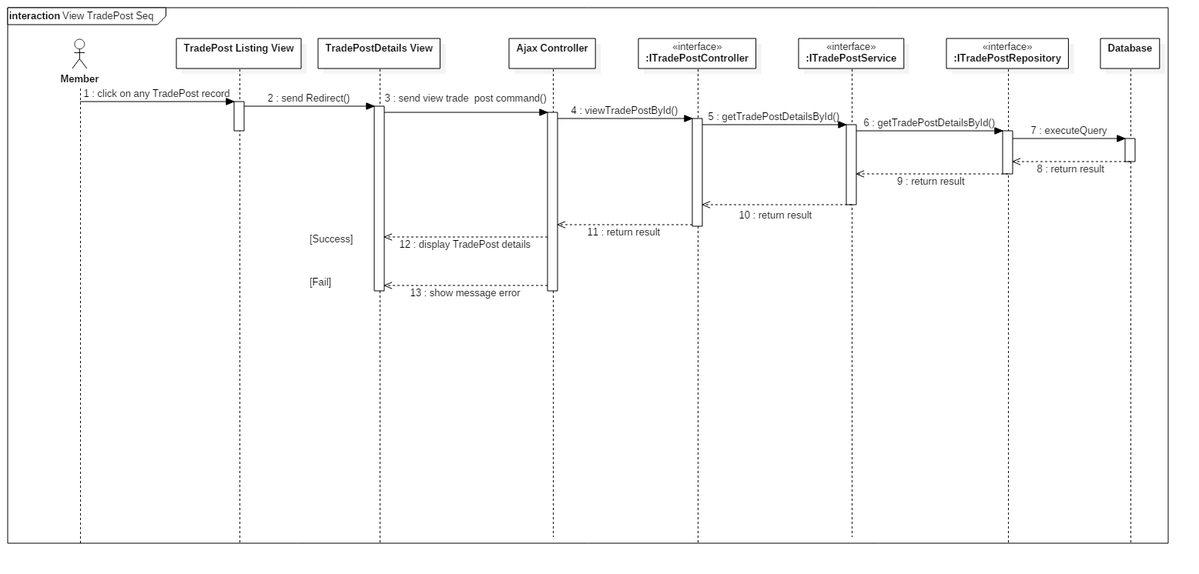 **4.3.1.6. Get Trade Post Detail Information**

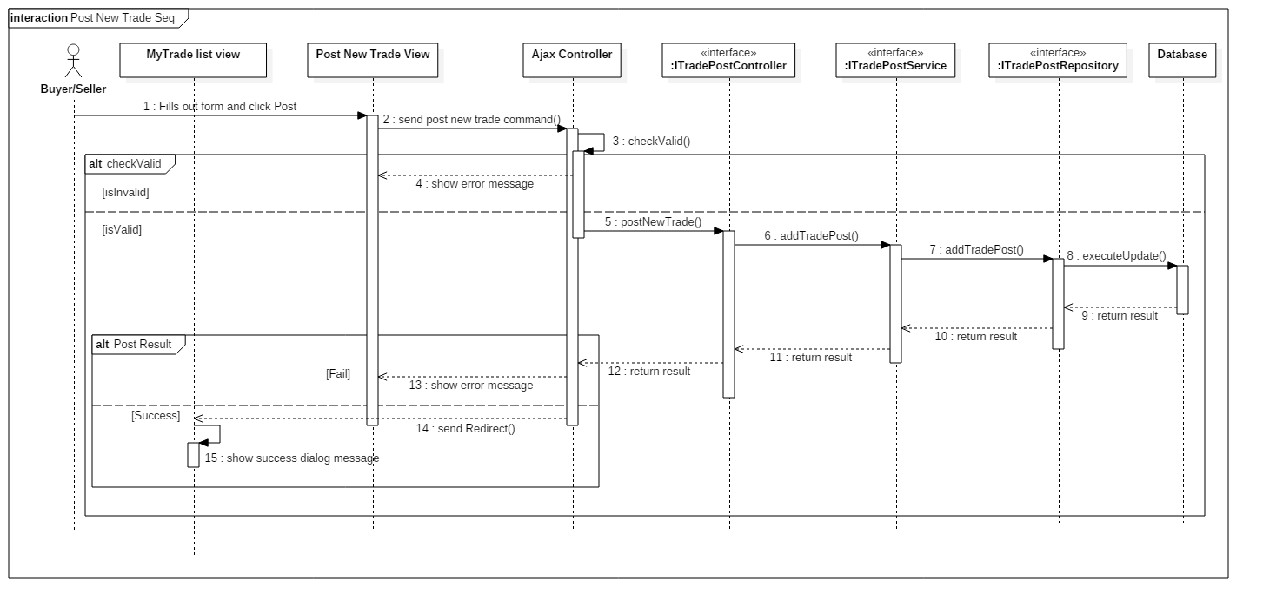 **4.3.1.7. Post new trade**

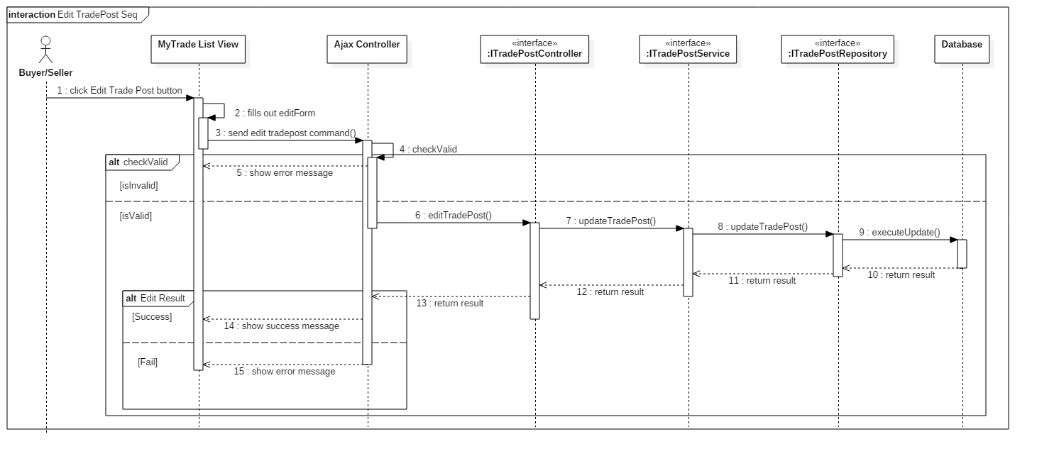 **4.3.1.8. Edit trade post**

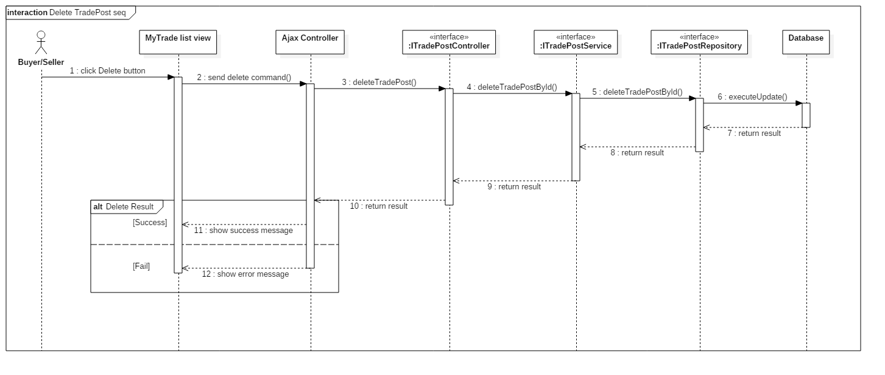 **4.3.1.9. Delete trade post**

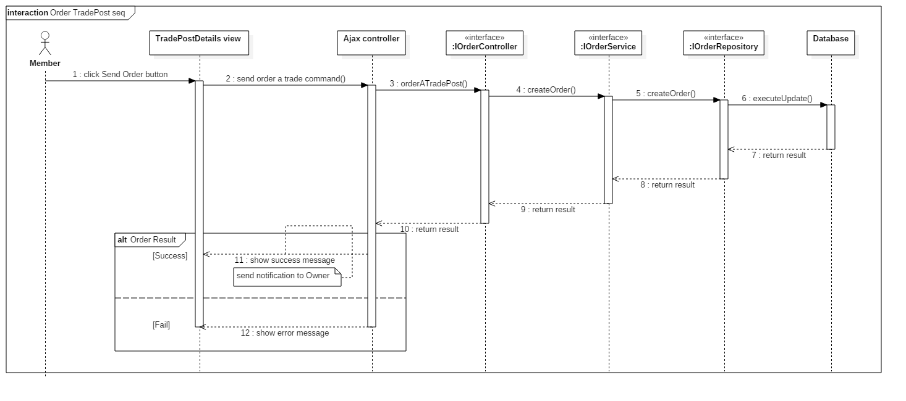 **4.3.1.10. Request order to a trade post**

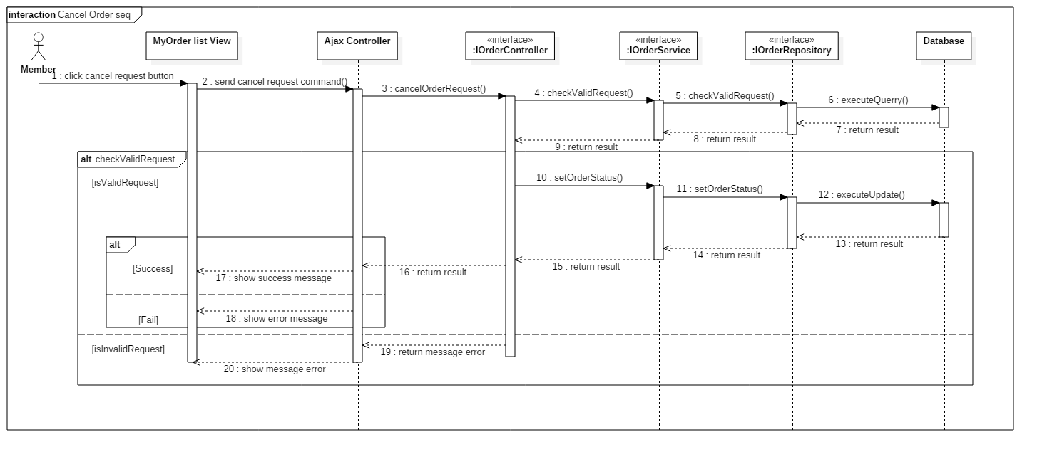 **4.3.1.11. Cancel an order**

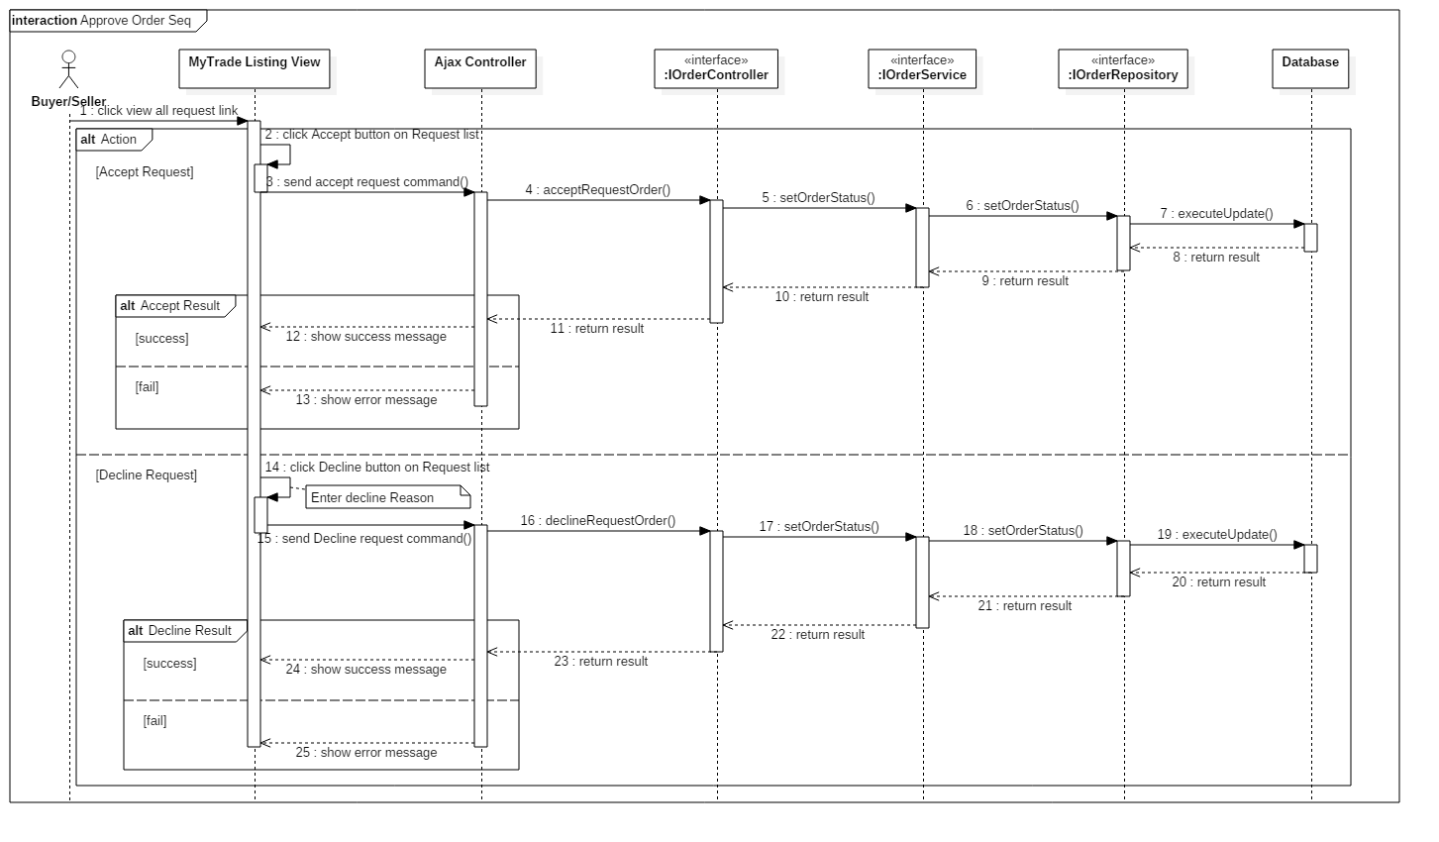 **4.3.1.12. Approve order request**

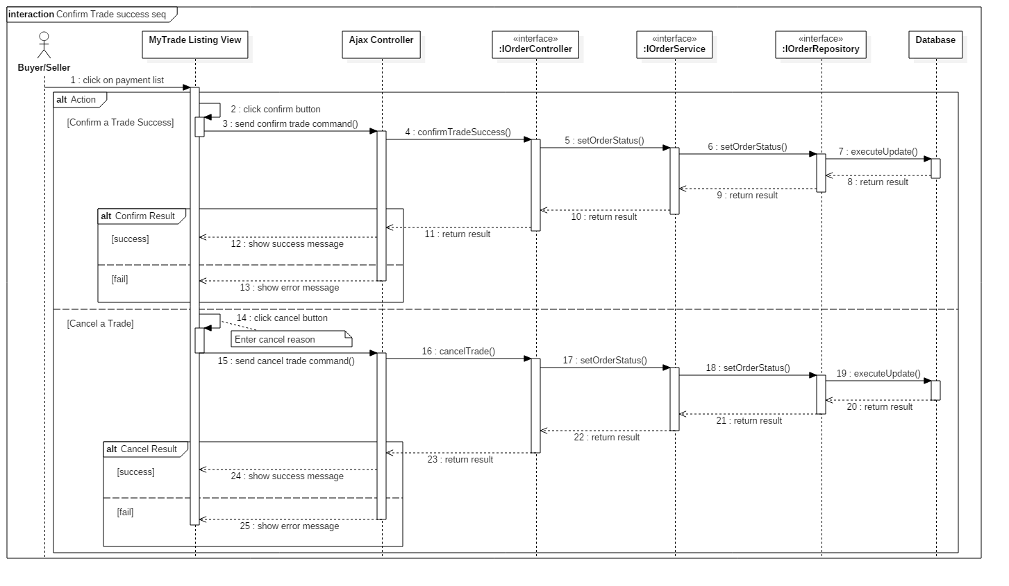 **4.3.1.13. Confirm trade success**

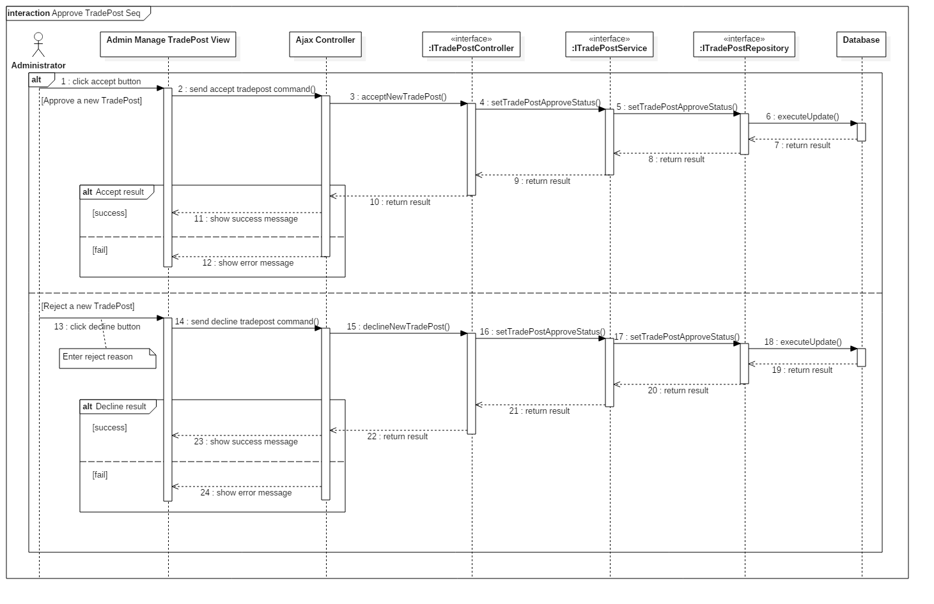 **4.3.1.14. Approve a trade post from buyer/seller**

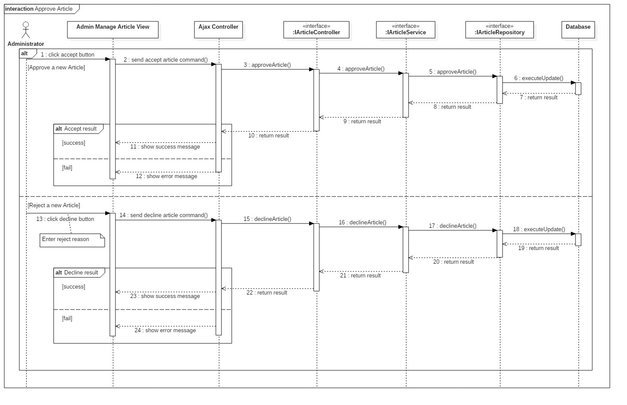 **4.3.1.15. Administrator approve member’s articles**

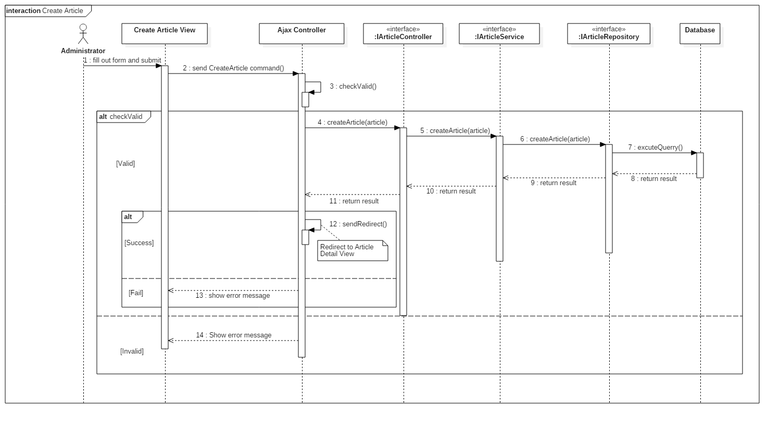 **4.3.1.16. Create new article**

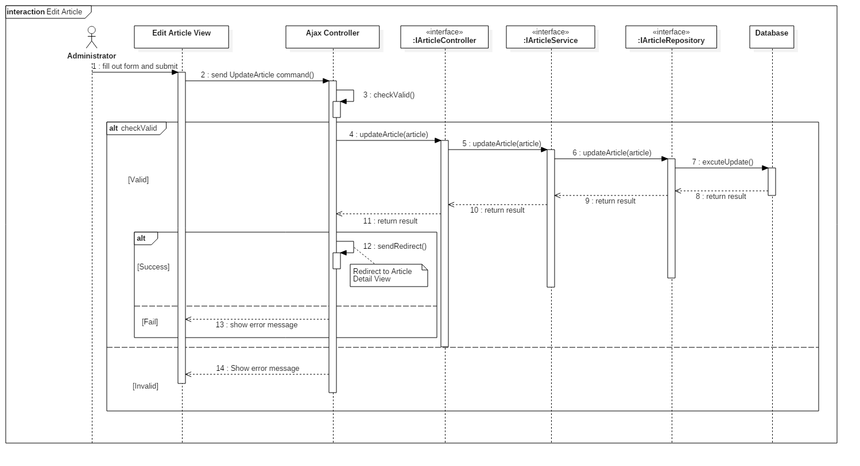 **4.3.1.17. Edit article**

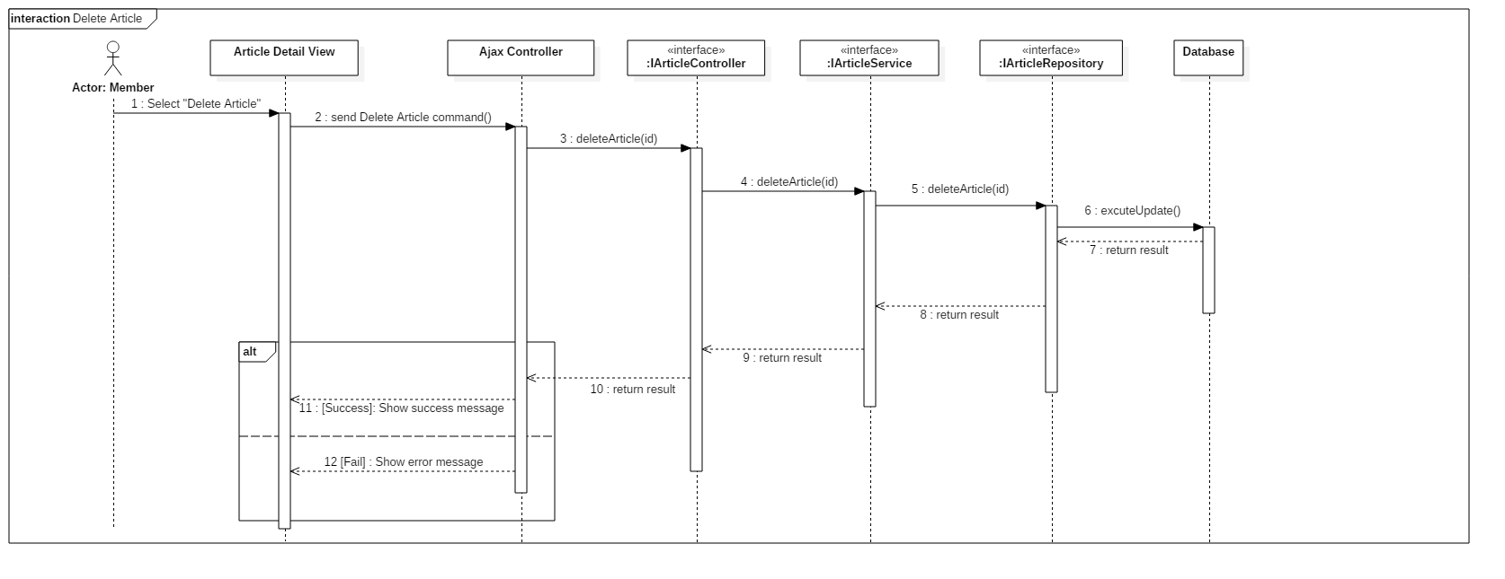 **4.3.1.18. Delete article**

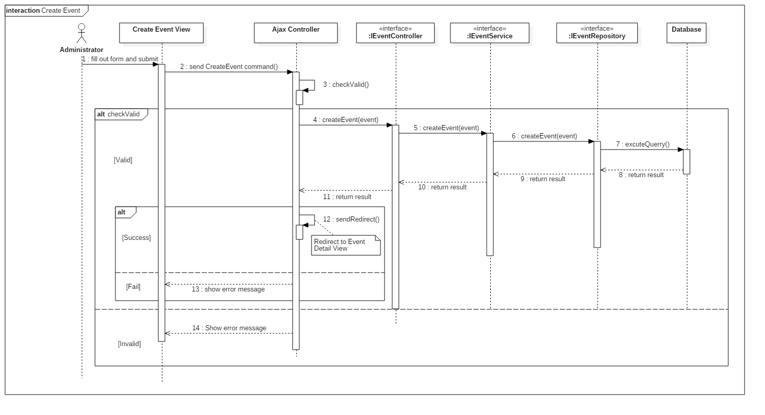 **4.3.1.19. Create event**

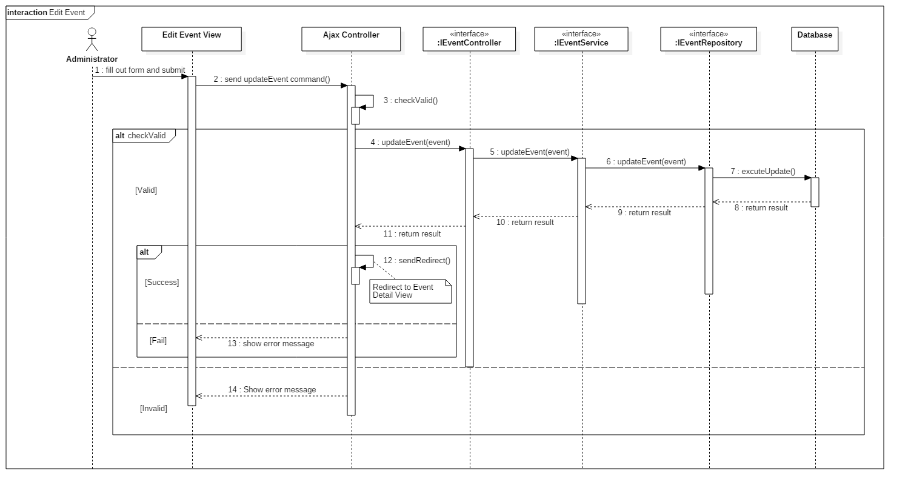 **4.3.1.20. Edit event**

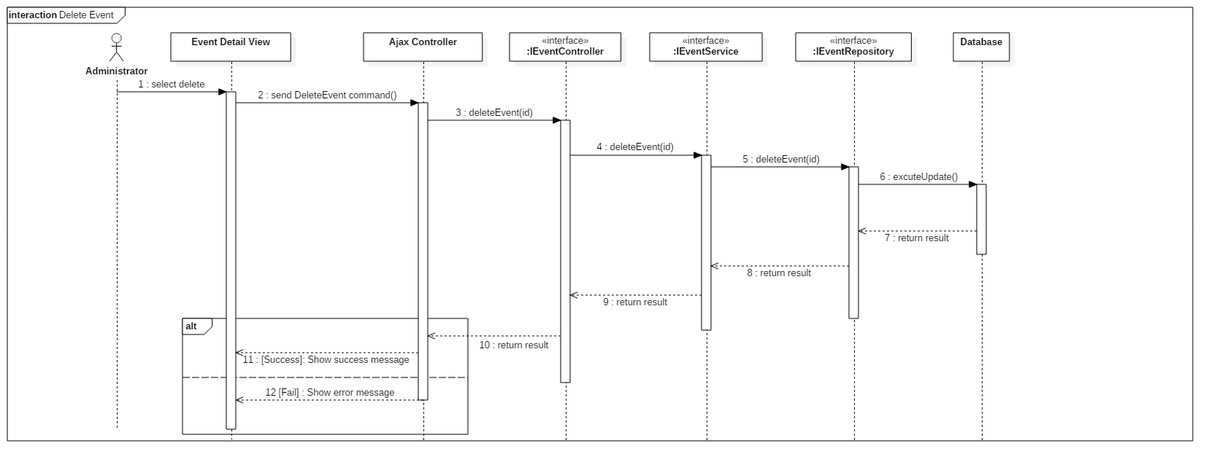 **4.3.1.21. Delete event**

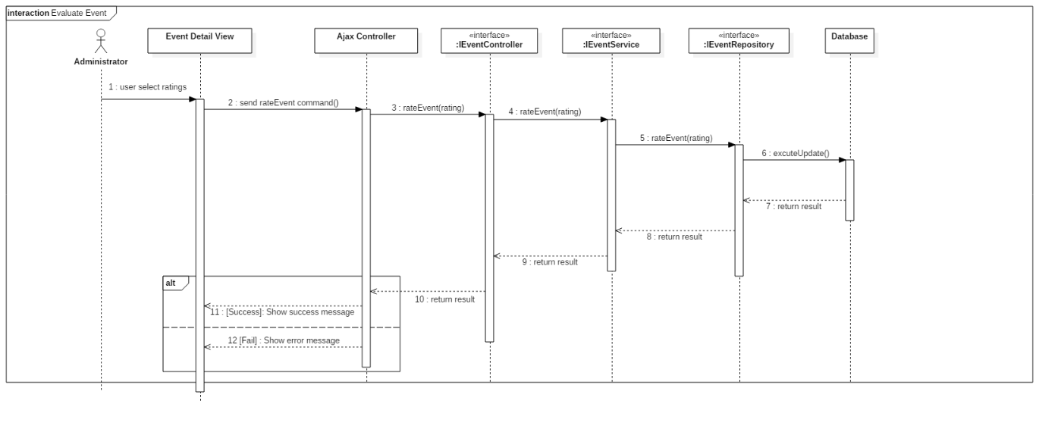 **4.3.1.22. Evaluate Event**

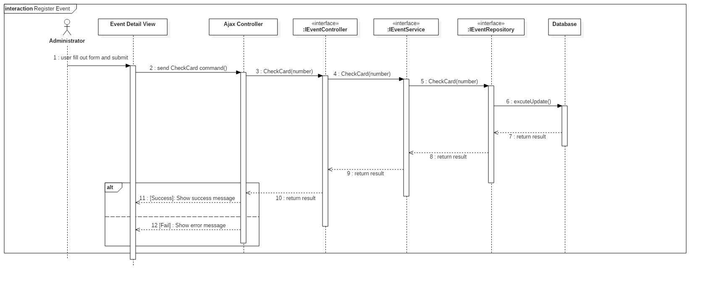 **4.3.1.23. Register event**

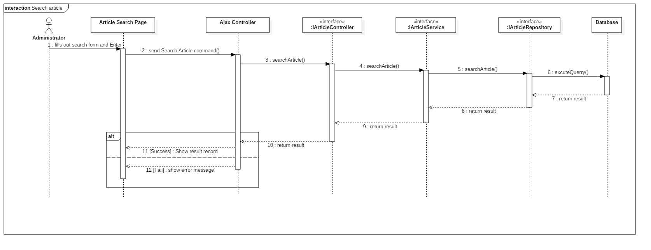 **4.3.1.24. Search article**

**5. Interface**

**5.1. Member**

**5.1.1. Web application**

**5.1.1.1. Display search model view**

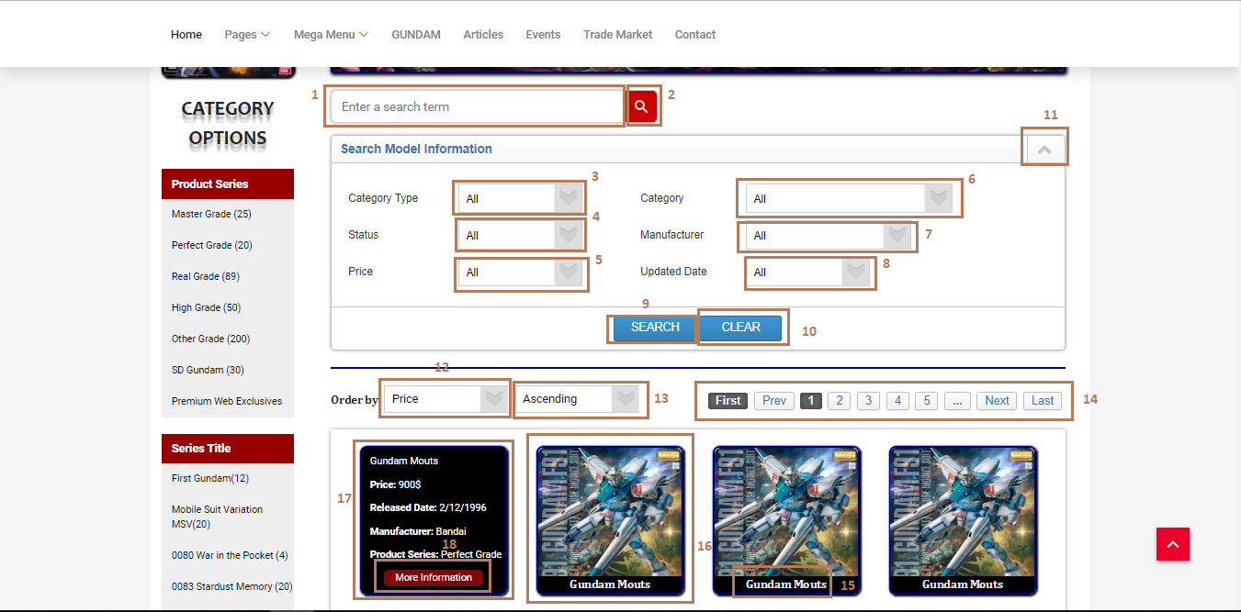

**Fields**

|  |  |  |  |  |  |  |  |
| --- | --- | --- | --- | --- | --- | --- | --- |
| **No** | **Field Name** | **Description** | **Read only** | **Mandatory** | **Control Type** | **Data Type** | **Length** |
| 1 | Search input text | Input search keyword, search by model name | No | No | Text input | String | N/A |
| 3 | CategoryType | Choose category types filter | No | No | Dropdown list | String | N/A |
| 4 | Status | Choose status filter | No | No | Dropdown list | String | N/A |
| 5 | Price | Choose price filter | No | No | Dropdown list | Float | N/A |
| 6 | Category | This field is loaded follow with user’s option in category type dropdown list, to choose the specified category | No | No | Dropdown list | String | N/A |
| 7 | Manufacturer | Choose manufacturer filter | No | No | Dropdown list | String | N/A |
| 8 | Updated Date | Choose updated date time filter | No | No | Dropdown list | String | N/A |
| 12 | Order By options | Choose order by options | No | No | Dropdown list | String | N/A |
| 13 | Ascending or Descending options | This dropdown list follows with order by dropdown list | No | No | Dropdwon list | String | N/A |
| 15 | Model name | Display model name | Yes | Yes | Label | String | N/A |
| 16 | Search record | Search record | Yes | Yes | N/A | N/A | N/A |
| 17 | Model detail info | Display model detail info when hover on a record | Yes | Yes | N/A | String | N/A |

**Buttons/Hyperlinks**

|  |  |  |  |  |
| --- | --- | --- | --- | --- |
| **No** | **Function** | **Description** | **Validation** | **Outcome** |
| 2 | Search | Send search command to server with value in search input text | N/A | List records match with the input keyword |
| 9 | Search with filters in search model information form | Send search command to server with values in search input text and all filters’s values in search model information form | N/A | List records match with the input keyword and the filters |
| 10 | Reset all field in search model information form | All dropdown list values will set to option “All” | N/A | All dropdown list values are set to option “All” |
| 11 | Open/close search information form | Open or close the search filters form | N/A | The search filters form will be pulled up/pushed down when click |
| 14 | Pagination | For paging with first, next, page numbers, next and last | N/A | The list records is updated match with page numbers |
| 18 | Redirect to the selected model’s detail page | Redirect to the selected model’s detail page | N/A | The selected model’s detail page is shown |

**5.1.1.2. Display model detail**

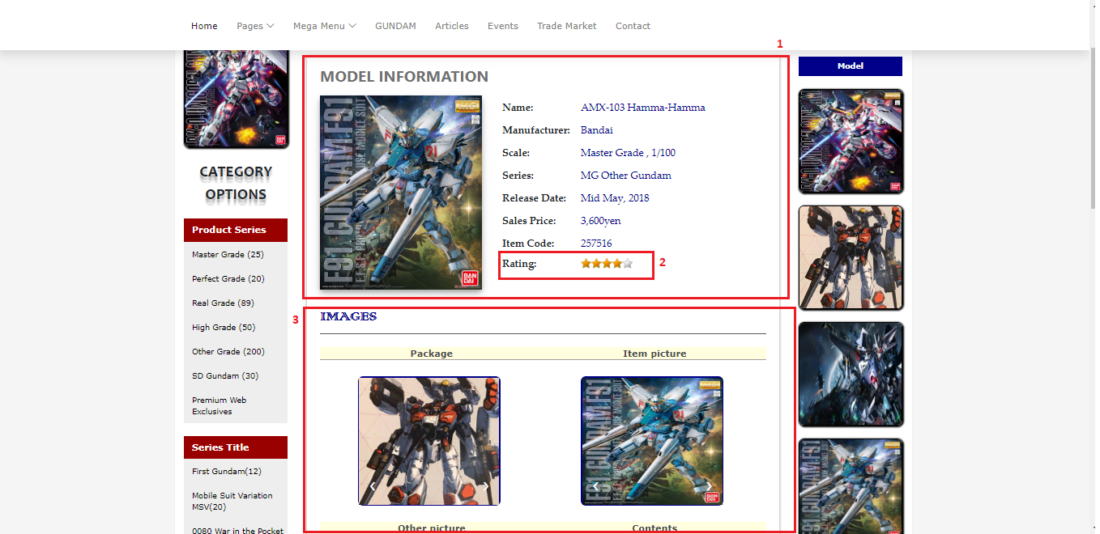

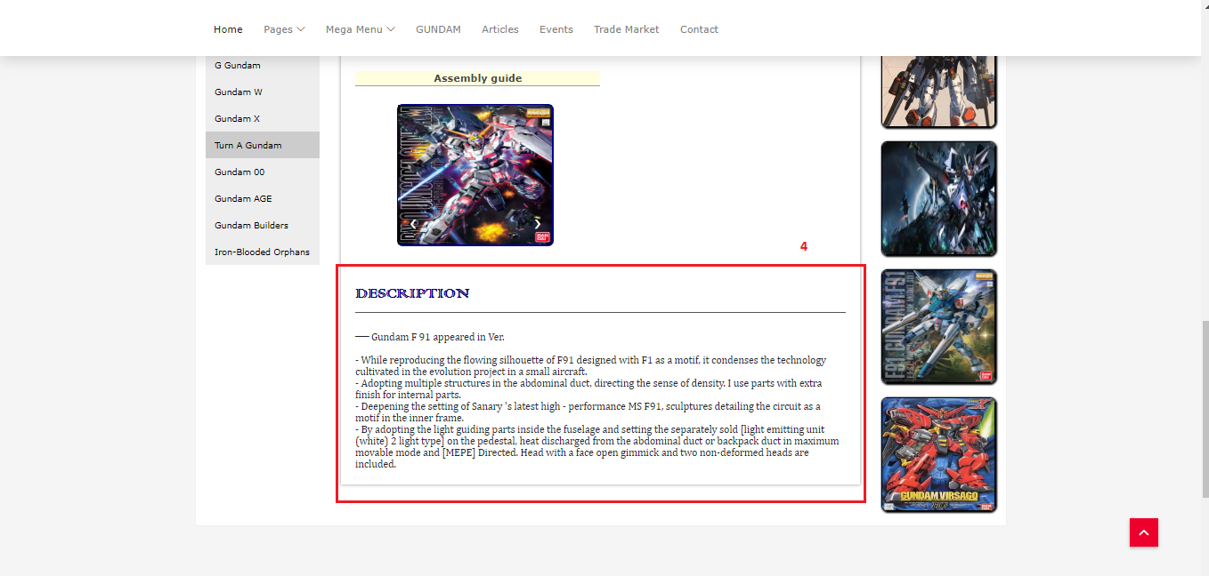

**Fields**

|  |  |  |  |  |  |  |  |
| --- | --- | --- | --- | --- | --- | --- | --- |
| **No** | **Field Name** | **Description** | **Read only** | **Mandatory** | **Control Type** | **Data Type** | **Length** |
| 1 | Model information | Model detail info | Yes | Yes | N/A | String | N/A |
| 3 | Model images | Model images | Yes | Yes | N/A | Img | N/A |
| 4 | Model description | Model’s description | Yes | Yes | N/A | String | N/A |

**Buttons/Hyperlinks**

|  |  |  |  |  |
| --- | --- | --- | --- | --- |
| **No** | **Function** | **Description** | **Validation** | **Outcome** |
| 2 | Rating | User evaluates a model | Each user can only  evaluate a model for one time | Model detail info with user’s rating |

**5.1.1.3. Display TradePost Listing view**

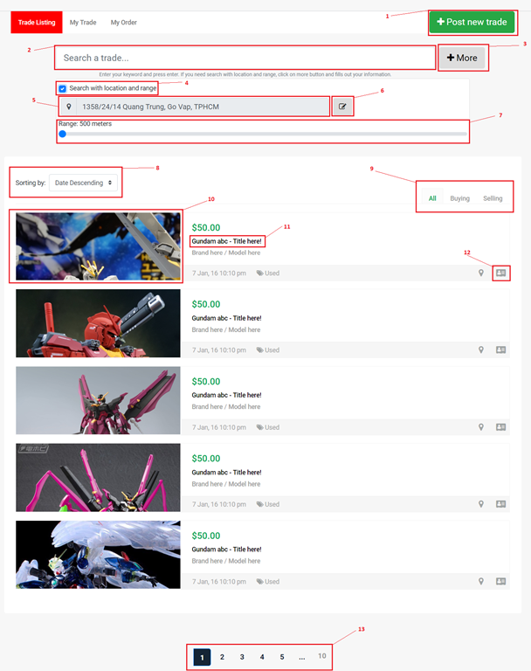

**Fields**

|  |  |  |  |  |  |  |  |
| --- | --- | --- | --- | --- | --- | --- | --- |
| **No** | **Field Name** | **Description** | **Read only** | **Mandatory** | **Control Type** | **Data Type** | **Length** |
| 2 | Search tradepost | Enter your keyword to search your tradepost. | No | Yes | Textbox | String | N/A |
| 4 | Search with location and range | Enable/Disable search with location and range | No | No | Checkbox | Boolean | N/A |
| 5 | Location | Display your location here | Yes | Yes | Textbox | String | N/A |
| 7 | Range | Slide to choose your range you want to search | No | Yes | Range input | Integer | N/A |
| 8 | Sorting | Select your sorting type. | No | Yes | Drop list | Integer | N/A |

**Buttons/Hyperlinks**

|  |  |  |  |  |
| --- | --- | --- | --- | --- |
| **No** | **Function** | **Description** | **Validation** | **Outcome** |
| 1 | Post New Trade | Go to Post New Trade page and display post new trade form. | N/A | Go to post new trade Page |
| 3 | More search | Show/Hide more search panel. | N/A | Show/Hide search form |
| 6 | Edit Location | Show Location editor modal. | N/A | Show edit modal |
| 9 | Change tab | Change tab view group by all/selling/buying. | N/A | Change tab |
| 10,11 | View TradePost details | Go to TradePost details view page to display all information about tradepost. | N/A | Go to post details Page |
| 12 | View owner profile | Go to tradepost owner profile. | N/A | Go to profile Page |
| 13 | Paging | Separate content to page list. | N/A | Change page content |

**5.1.1.4. Display TradePost details view**

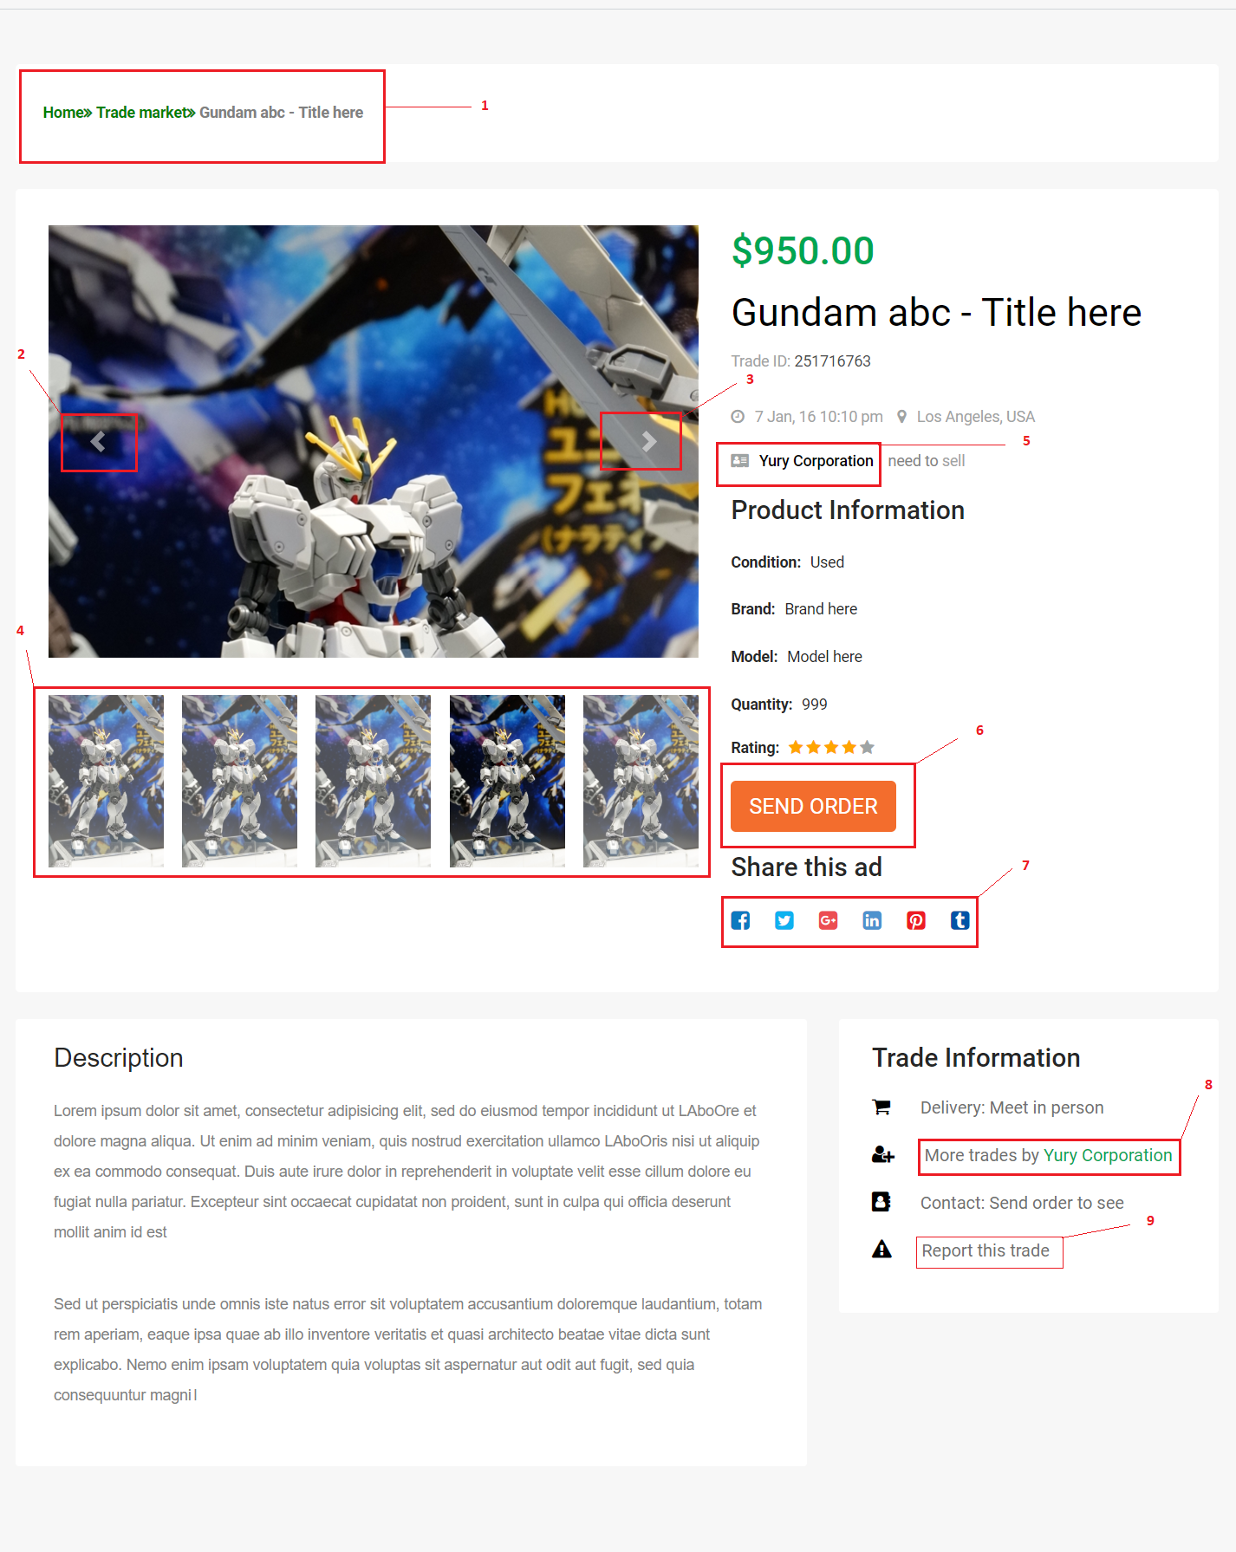

**Fields:** N/A

**Buttons/Hyperlinks**

|  |  |  |  |  |
| --- | --- | --- | --- | --- |
| **No** | **Function** | **Description** | **Validation** | **Outcome** |
| 1 | Page Address | Show address link to explore post. | N/A | Go to Page |
| 2 | Previous Image | Previous control for product Image slideshow. | N/A | Click for previous Image. |
| 3 | Next Image | Next control for product Image slideshow. | N/A | Click for next Image. |
| 4 | Slideshow indicator | List images in slideshow. Click to view this image. | N/A | Change Image. |
| 5 | Owner link | Click to go to owner profile page. | N/A | Go to profile Page |
| 6 | Send order button | Click to show send order modal. | N/A | Show  send order modal |
| 7 | Share this trade button list | Click on any social button to share this trade. | N/A | Share link to social page. |
| 8 | More trade post from owner | Click to show modal with trade post list from this trade post owner. | N/A | Show more post modal |
| 9 | Report button | Click to show report form. | N/A | Show report modal. |

**5.1.1.5. Display MyOrder view**

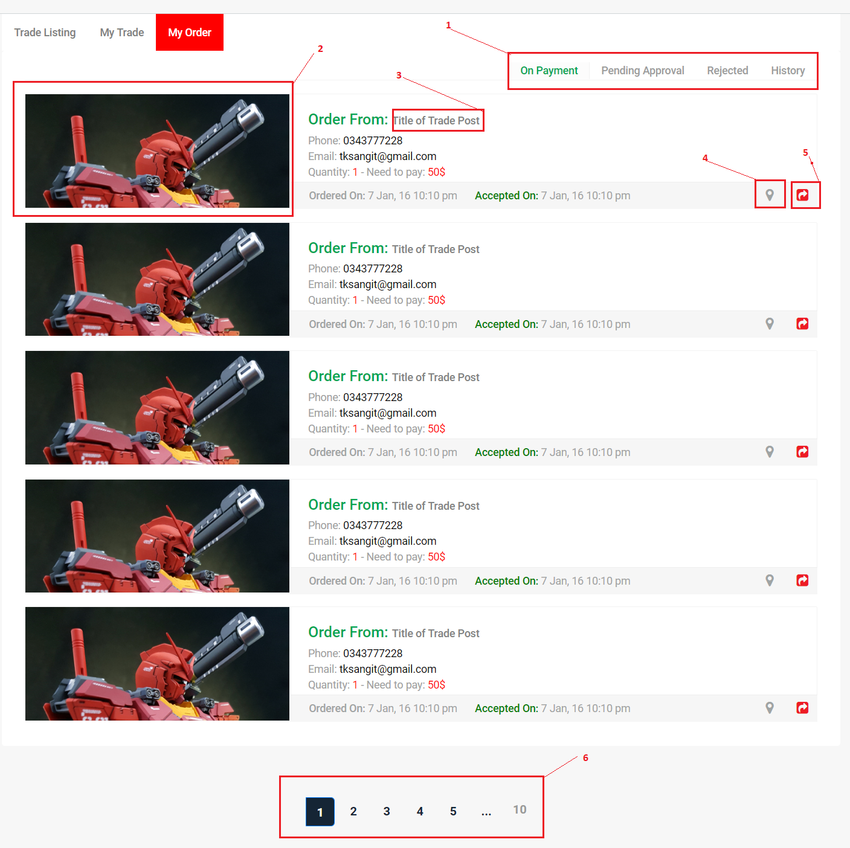

**Fields:** N/A

**Buttons/Hyperlinks:**

|  |  |  |  |  |
| --- | --- | --- | --- | --- |
| No | Function | Description | Validation | Outcome |
| 1 | Change tab | Click to change tab. | N/A | Change tab group |
| 2,3 | View Post details | Click to go to trade post details page. | N/A | Go to details page. |
| 4 | Get direction | Click to get direction to trade post owner. | N/A | Show direction modal. |
| 5 | Cancel order | Click to cancel order. | N/A | Show cancel order modal. |
| 6 | Paging | Separate content to page list. | N/A | Change page content. |

**5.1.1.6. Display article listing view**

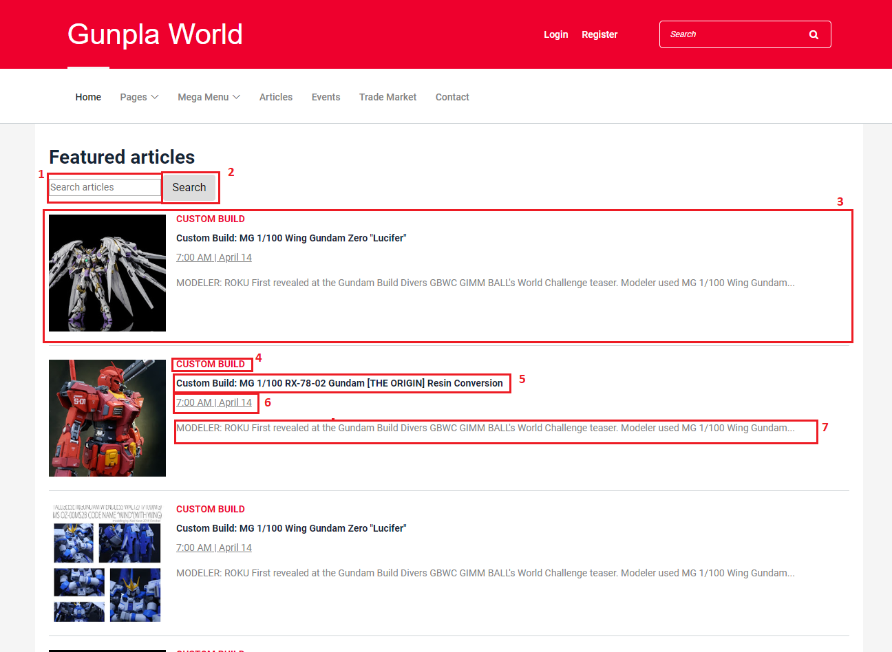

**Fields**

|  |  |  |  |  |  |  |  |
| --- | --- | --- | --- | --- | --- | --- | --- |
| **No** | **Field Name** | **Description** | **Read only** | **Mandatory** | **Control Type** | **Data Type** | **Length** |
| 1 | Search input text | Input search keyword, search by article title | No | No | Text input | String | N/A |
| 3 | Search record | Result record from searching | Yes | No | N/A | N/A | N/A |
| 6 | Article’s date | The day that the article was posted on | Yes | No | N/A | String | N/A |

**Buttons/Hyperlinks**

|  |  |  |  |  |
| --- | --- | --- | --- | --- |
| **No** | **Function** | **Description** | **Validation** | **Outcome** |
| 2 | Search | Send search command to server with value in search input text | N/A | List records match with the input keyword |
| 4 | Article category | The category that this article belongs to | N/A | Search articles with that category |
| 5 | Article’s title | Title of the article | N/A | Redirects to the article’s detail view |
| 7 | Article’s content | A short part of the article’s description | N/A | Redirects to the article’s detail view |

**5.1.1.7. Article detail view**

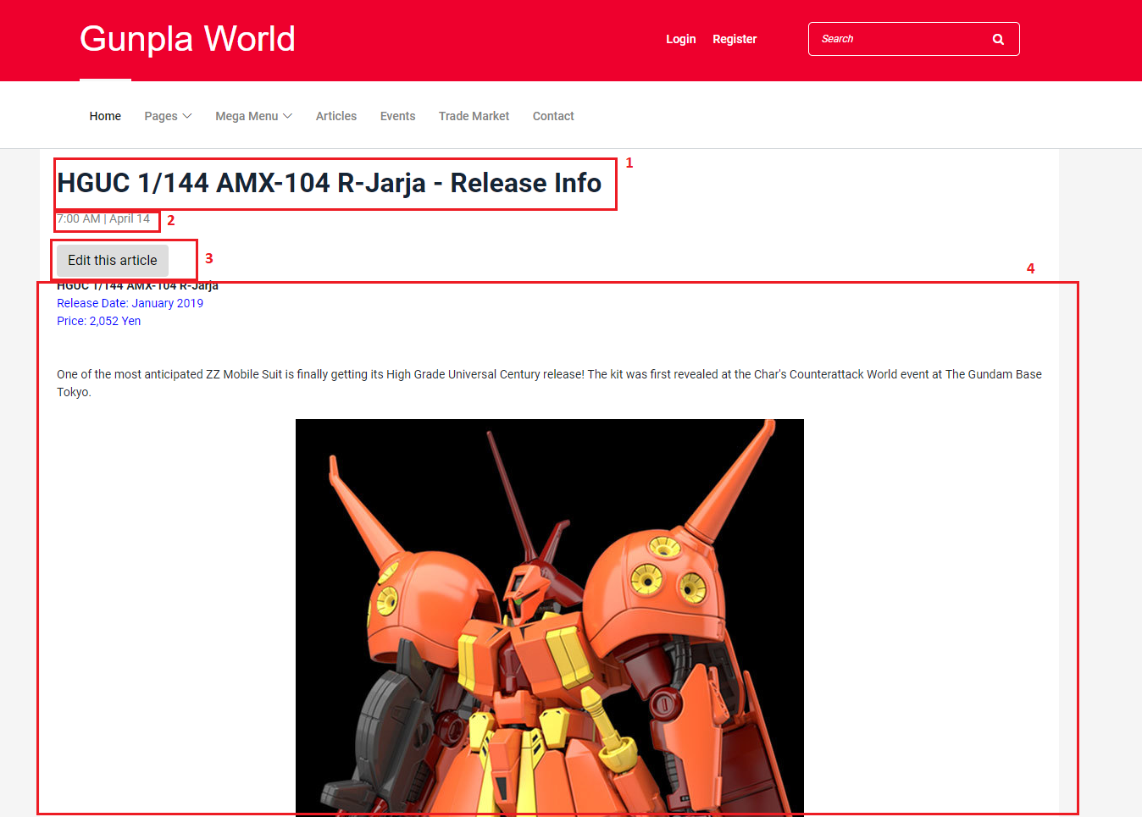

**Fields**

|  |  |  |  |  |  |  |  |
| --- | --- | --- | --- | --- | --- | --- | --- |
| **No** | **Field Name** | **Description** | **Read only** | **Mandatory** | **Control Type** | **Data Type** | **Length** |
| 1 | Article’s title | The title of the article | Yes | No | N/A | String | N/A |
| 2 | Article’s date | The day that the article was posted on | Yes | No | N/A | String | N/A |
| 4 | Article’s content | The content of the article | Yes | No | N/A | String | N/A |

**Buttons/Hyperlinks**

|  |  |  |  |  |
| --- | --- | --- | --- | --- |
| **No** | **Function** | **Description** | **Validation** | **Outcome** |
| 3 | Edit this article | Let the user edit the article | N/A | Redirects the user to the edit article view |

**5.1.1.8. Edit Article view**

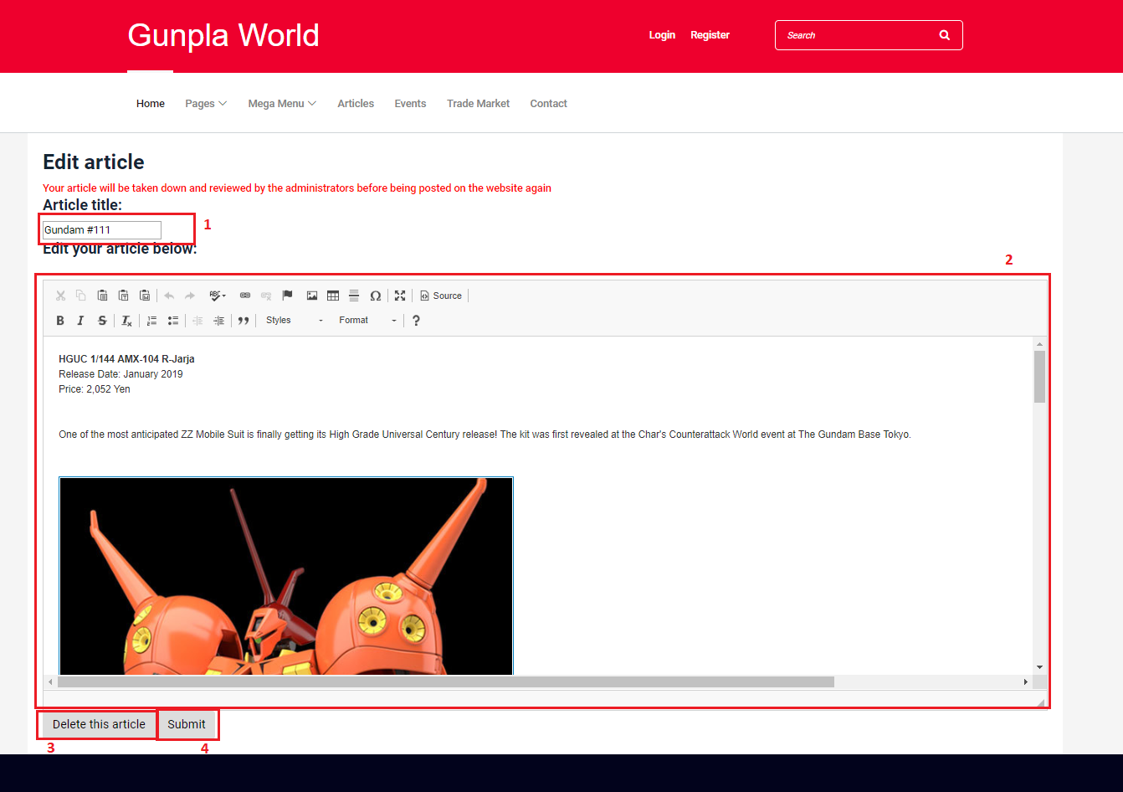

**Fields**

|  |  |  |  |  |  |  |  |
| --- | --- | --- | --- | --- | --- | --- | --- |
| **No** | **Field Name** | **Description** | **Read only** | **Mandatory** | **Control Type** | **Data Type** | **Length** |
| 1 | Article’s title | The title of the article | No | Yes | N/A | String | N/A |
| 2 | Article’s content | The content of the article | No | Yes | N/A | String | N/A |

**Buttons/Hyperlinks**

|  |  |  |  |  |
| --- | --- | --- | --- | --- |
| **No** | **Function** | **Description** | **Validation** | **Outcome** |
| 3 | Delete this article | Let the user delete the article | N/A | Prompts the user for confirmation before deleting the article |
| 4 | Submit | Submit the article | All required fields must not be empty | Success: article’s information is saved to the database and redirects the user to that article’s page.  Failure: show error message |

**5.1.1.9. Event list view**

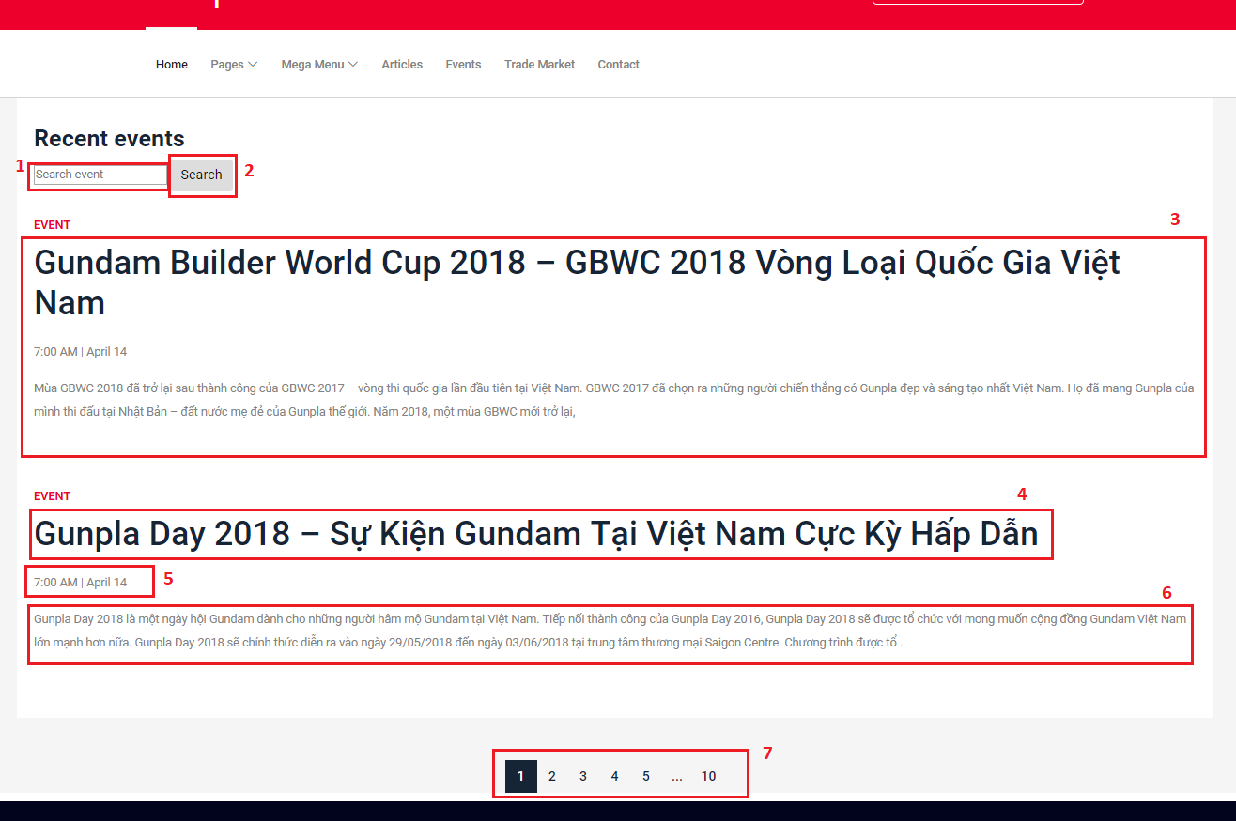

**Fields**

|  |  |  |  |  |  |  |  |
| --- | --- | --- | --- | --- | --- | --- | --- |
| **No** | **Field Name** | **Description** | **Read only** | **Mandatory** | **Control Type** | **Data Type** | **Length** |
| 1 | Search input text | Input search keyword, search by article title | No | No | N/A | String | N/A |
| 3 | Search result | Event records from searching | No | No | N/A | String | N/A |

**Buttons/Hyperlinks**

|  |  |  |  |  |
| --- | --- | --- | --- | --- |
| **No** | **Function** | **Description** | **Validation** | **Outcome** |
| 2 | Search | Search event by title | N/A | List records match with the input keyword |
| 4 | Event’s title | The title of the event | N/A | Redirects the user to the event’s detail view |
| 5 | Event’s date | The date the event was posted on | N/A | Redirects the user to the event’s detail view |
| 6 | Event’s content | A short part of the event’s content | N/A | Redirects the user to the event’s detail view |

**5.1.1.10. Event detail view**

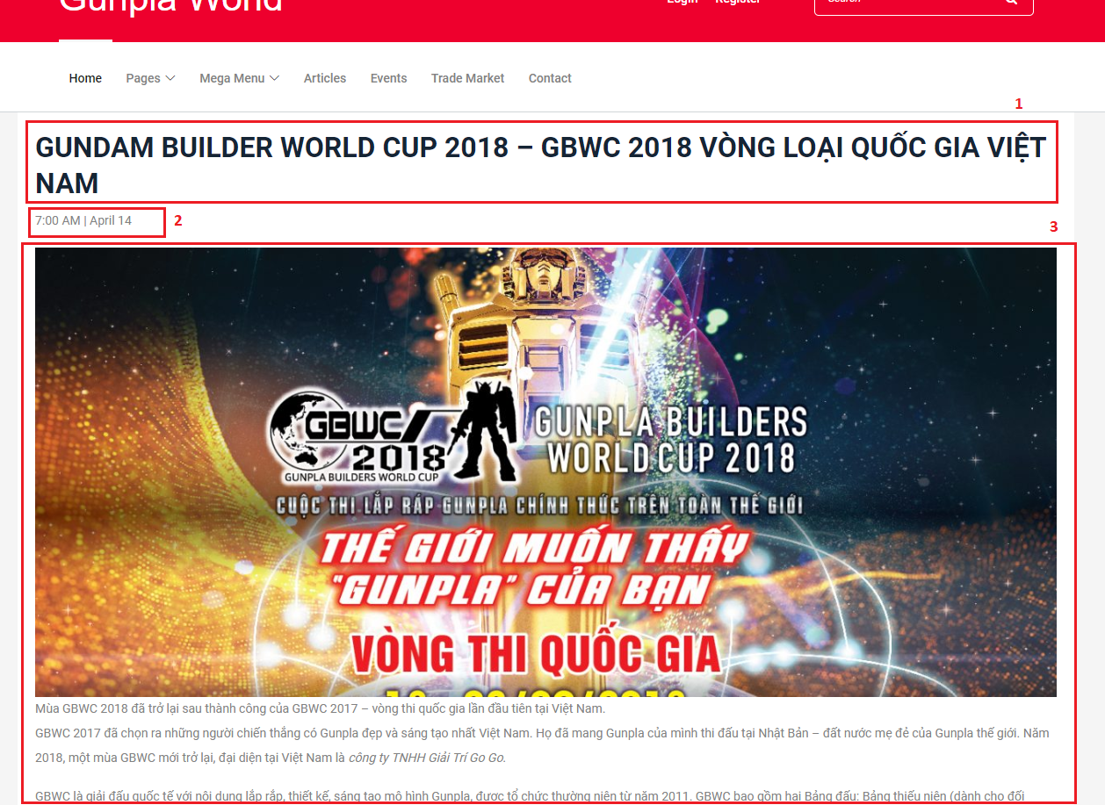

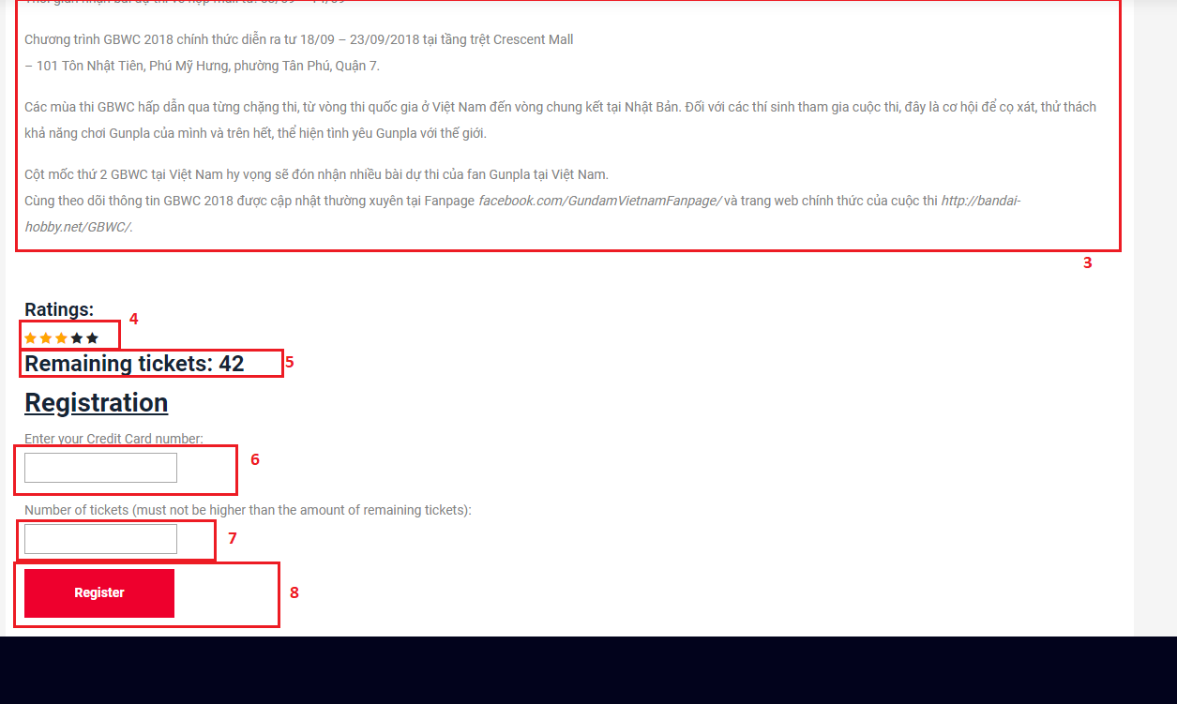

**Fields**

|  |  |  |  |  |  |  |  |
| --- | --- | --- | --- | --- | --- | --- | --- |
| **No** | **Field Name** | **Description** | **Read only** | **Mandatory** | **Control Type** | **Data Type** | **Length** |
| 1 | Event’s title | The event’s title | Yes | Yes | N/A | String | N/A |
| 2 | Event’ date | The date the event was posted on | Yes | Yes | N/A | String | N/A |
| 3 | Event’s content | The content of the event | Yes | Yes | N/A | String | N/A |
| 5 | Remaining tickets | The amount of tickets left available | Yes | Yes | N/A | String | N/A |
| 6 | Credit card number input | The number of member’s credit card | No | No | N/A | String | N/A |
| 7 | Number of tickets | The number of tickets the user wants to buy | No | Yes | N/A | String | N/A |

**Buttons/Hyperlinks**

|  |  |  |  |  |
| --- | --- | --- | --- | --- |
| **No** | **Function** | **Description** | **Validation** | **Outcome** |
| 4 | Ratings | Rate the event from 1-5 stars | N/A | Save the ratings to database |
| 8 | Register | Register the user to the event | N/A | Add the user to the list of event’s attendees |

**5.1.2. Mobile application**

**5.2. Buyer/Seller**

**5.2.1. Web application**

**5.2.1.1. Display Post New TradePost view**

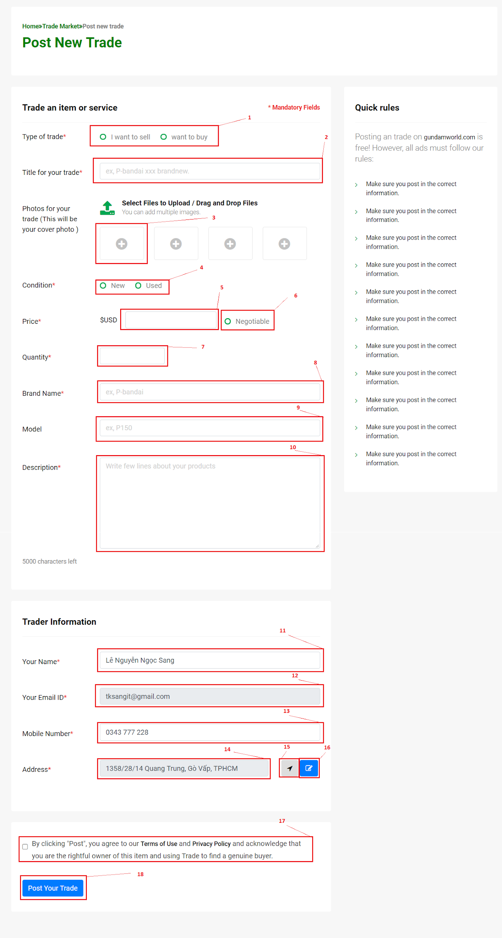

**Fields**

|  |  |  |  |  |  |  |  |
| --- | --- | --- | --- | --- | --- | --- | --- |
| **No** | **Field Name** | **Description** | **Read only** | **Mandatory** | **Control Type** | **Data Type** | **Length** |
| 1 | Type of trade | Select your type of trade: sell or buy | No | Yes | Radio button group | Integer | N/A |
| 2 | Title of your trade | Type your title here. | No | Yes | Textbox | String | N/A |
| 3 | Upload Image | Click to choose your image. | No | Yes | File | Image file type: png ,jpeg, jpg, gif | N/A |
| 4 | Condition | Choose your product condition: Used or New | No | Yes | Radio button group | Integer | N/A |
| 5 | Price | Type your price here | No | Yes | Textbox | String | N/A |
| 6 | Price Negotiable | Set your price can negotiable: Yes or No | No | No | Radio button | Boolean | N/A |
| 7 | Quantity | Type your quantity here | No | Yes | Textbox | Integer | N/A |
| 8 | Brand name | Type your product brand here | No | No | Textbox | String | N/A |
| 9 | Model | Type your product model here | No | No | Textbox | String | N/A |
| 10 | Description | Type your product description here | No | Yes | Textbox | String | N/A |
| 11 | Your name | Input your name here | No | Yes | Textbox | String | N/A |
| 12 | Your Email | Your email will show here | Yes | Yes | Textbox | String | N/A |
| 13 | Mobile Number | Input your mobile number here | No | Yes | Textbox | String | N/A |
| 14 | Address | Your location will show here | Yes | No | Textbox | String | N/A |
| 17 | Agree term | You need agree button to post your trade | No | Yes | Radio button | Boolean | N/A |

**Buttons/Hyperlinks**

|  |  |  |  |  |
| --- | --- | --- | --- | --- |
| **No** | **Function** | **Description** | **Validation** | **Outcome** |
| 15 | Auto get your location | Click to auto get your location and fills result to address field. | N/A | Call auto get location function |
| 16 | Edit your location | Click to show modal to select correct your location | N/A | Show  edit location modal |
| 18 | Post your trade | Click to submit your trade post | N/A | Submit form. |

**5.2.1.2. Display My trade view**

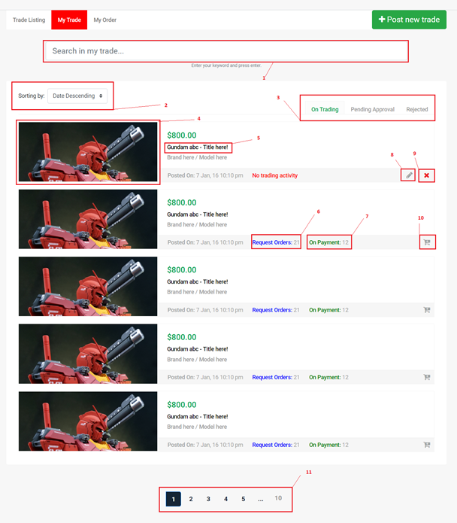

**Fields**

|  |  |  |  |  |  |  |  |
| --- | --- | --- | --- | --- | --- | --- | --- |
| **No** | **Field Name** | **Description** | **Read only** | **Mandatory** | **Control Type** | **Data Type** | **Length** |
| 1 | Search in my trade | Enter your keyword to search your tradepost. | No | Yes | Textbox | String | N/A |
| 2 | Sorting | Select your sorting type. | No | Yes | Drop list | Integer | N/A |

**Buttons/Hyperlinks**

|  |  |  |  |  |
| --- | --- | --- | --- | --- |
| **No** | **Function** | **Description** | **Validation** | **Outcome** |
| 3 | Change tab | Change tab view group by On trading/Pending Approval/Rejected | N/A | Change page content |
| 4,5 | View TradePost details | Go to TradePost details view page to display all information about tradepost. | N/A | Go to post details Page |
| 6 | View all Request Order | View all request order for the trade post. | N/A | Show  all request modal |
| 7 | View all On Payment | View all on payment for the trade post. | N/A | Show  on payment modal |
| 8 | Edit this trade | Edit information of this trade. | N/A | Show  edit modal |
| 9 | Delete this trade | Delete the trade | N/A | Show delete modal |
| 10 | Update Quantity | Update trade quantity | N/A | Show update quantity modal |
| 11 | Paging | Separate content to page list. | N/A | Change page content |

**5.2.2. Mobile Application**

**5.3. Guest**

**5.3.1. Web application**

**5.3.1.1. Register account**

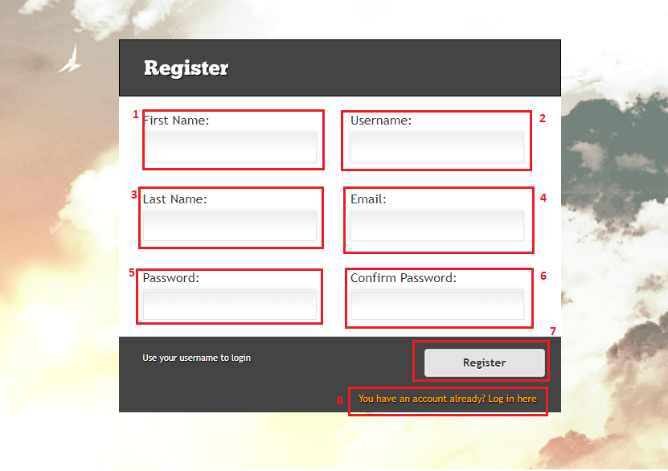

**Fields**

|  |  |  |  |  |  |  |  |
| --- | --- | --- | --- | --- | --- | --- | --- |
| **No** | **Field Name** | **Description** | **Read only** | **Mandatory** | **Control Type** | **Data Type** | **Length** |
| 1 | Firstname | User’s first name | No | Yes | Text input | String | <= 50 |
| 2 | Username | User’s username for login | No | Yes | Text input | String | <= 50 |
| 3 | Lastname | User’s lastname | No | Yes | Text input | String | <= 50 |
| 4 | Email | User’s email | No | Yes | Text input | String | <= 50 |
| 5 | Password | User’s password | No | Yes | Text input | String | <= 50 |
| 6 | ConfirmPassword | To confirm password, this field’s value must be the same as password | No | Yes | Text input | String | N/A |

**Buttons/Hyperlinks**

|  |  |  |  |  |
| --- | --- | --- | --- | --- |
| **No** | **Function** | **Description** | **Validation** | **Outcome** |
| 7 | Register | Send register command with values | Entered email must match the required format  Entered email and username must not be duplicate in database  Length of field’s value must not be out of range  Password and confirm password must match to each other  All required fields must be filled out | Login page with register success message |
| 8 | Redirect to login page | For whom already had account | N/A | Login page |

**5.3.1.2. Login**

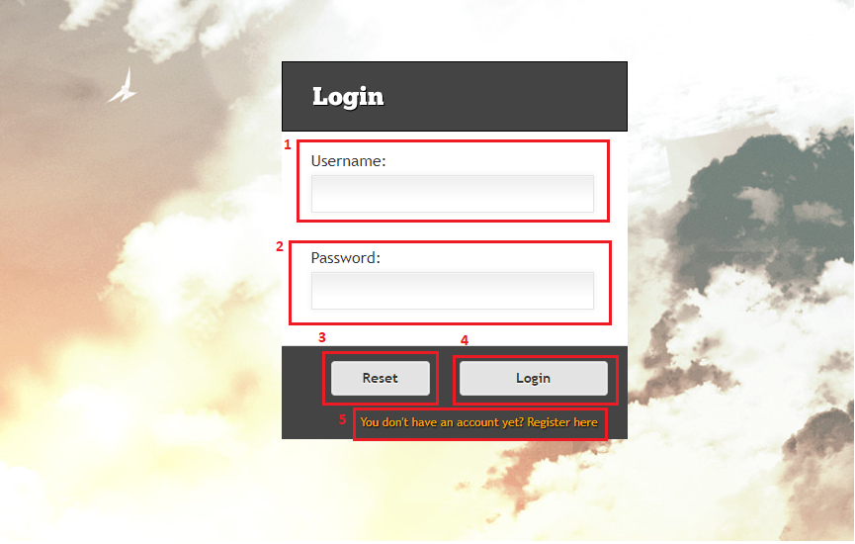

**Fields**

|  |  |  |  |  |  |  |  |
| --- | --- | --- | --- | --- | --- | --- | --- |
| **No** | **Field Name** | **Description** | **Read only** | **Mandatory** | **Control Type** | **Data Type** | **Length** |
| 1 | Username | User’s username | No | Yes | Text input | String | N/A |
| 2 | Password | User’s password | No | Yes | Text input | String | N/A |

**Buttons/Hyperlinks**

|  |  |  |  |  |
| --- | --- | --- | --- | --- |
| **No** | **Function** | **Description** | **Validation** | **Outcome** |
| 3 | Reset | Reset all fields | N/A | All fields are clear |
| 4 | Login | Send login command to the system with username and password | Check exist in database | Success: show homepage  Fail: show error message |
| 5 | Redirect to Register page | For whom doesn’t have an account | N/A | Register page is shown |

**5.3.2. Mobile application**

**5.4. Authenticated User**

**5.4.1. Web application**

**5.4.1.1. Get profile**

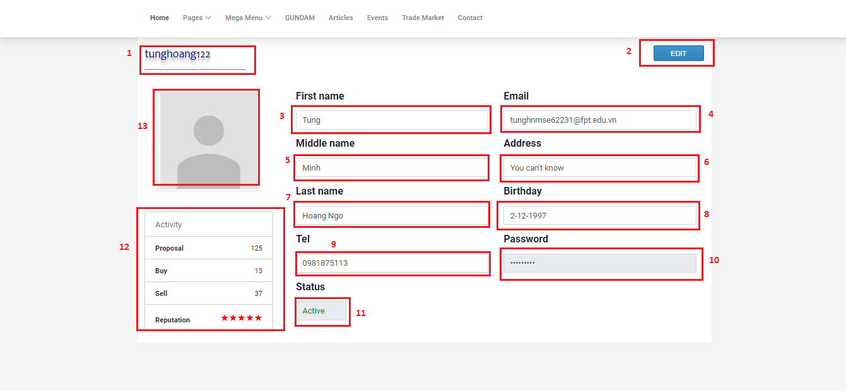

**Fields**

|  |  |  |  |  |  |  |  |
| --- | --- | --- | --- | --- | --- | --- | --- |
| **No** | **Field Name** | **Description** | **Read only** | **Mandatory** | **Control Type** | **Data Type** | **Length** |
| 1 | Username | User’s username for login | Yes | Yes | Label | String | <= 50 |
| 3 | Firstname | User’s firstname | Yes | Yes | Text input | String | <= 50 |
| 4 | Email | User’s email | Yes | Yes | Text input | String | <=50 |
| 5 | Middlename | User’s middle name | Yes | No | Text input | String | <=50 |
| 6 | Address | User’s address | Yes | No | Text input | String | <= 250 |
| 7 | Lastname | User’s lastname | Yes | Yes | Text input | String | <= 50 |
| 8 | Birthday | User’s birthday | Yes | No | DateTimePicker | String | <= 20 |
| 9 | Tel | User’s mobile number | Yes | No | Text input | String | 10-11 |
| 10 | Password | User’s password | Yes | Yes | Text input | String | <= 50 |
| 11 | Status | User’s status | Yes | Yes | Text input | String | N/A |
| 12 | Statistic | User’s statistics and ratings | Yes | Yes | N/A | String | N/A |
| 13 | Avatar | User’s image | Yes | Yes | Img | Img | N/A |

**Buttons/Hyperlinks**

|  |  |  |  |  |
| --- | --- | --- | --- | --- |
| **No** | **Function** | **Description** | **Validation** | **Outcome** |
| 2 | Edit | Redirect to edit page | N/A | Edit page is shown |

**5.4.1.2. Edit profile**

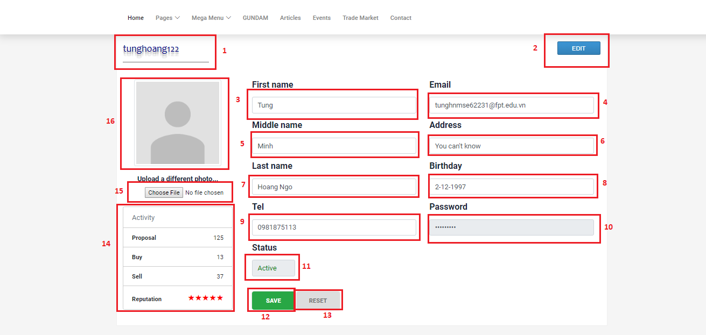

**Fields**

|  |  |  |  |  |  |  |  |
| --- | --- | --- | --- | --- | --- | --- | --- |
| **No** | **Field Name** | **Description** | **Read only** | **Mandatory** | **Control Type** | **Data Type** | **Length** |
| 1 | Username | User’s username for login | Yes | Yes | Label | String | <= 50 |
| 3 | Firstname | User’s firstname | No | Yes | Text input | String | <= 50 |
| 4 | Email | User’s email | No | Yes | Text input | String | <=50 |
| 5 | Middlename | User’s middle name | No | No | Text input | String | <=50 |
| 6 | Address | User’s address | No | No | Text input | String | <= 250 |
| 7 | Lastname | User’s lastname | No | Yes | Text input | String | <= 50 |
| 8 | Birthday | User’s birthday | No | No | DateTimePicker | String | <= 20 |
| 9 | Tel | User’s mobile number | No | No | Text input | String | 10-11 |
| 10 | Password | User’s password | Yes | Yes | Text input | String | <= 50 |
| 11 | Status | User’s status | Yes | Yes | Text input | String | N/A |
| 14 | Statistic | User’s statistics and ratings | Yes | Yes | N/A | String | N/A |
| 16 | Avatar | User’s image | No | Yes | Img | Img | N/A |

**Buttons/Hyperlinks**

|  |  |  |  |  |
| --- | --- | --- | --- | --- |
| **No** | **Function** | **Description** | **Validation** | **Outcome** |
| 2 | Edit | Redirect to edit page | N/A | Edit page is shown |
| 12 | Save | Send edit profile with values | Email must match the required format  All required fields must be filled out  Phone number is string of number  Email must not be duplicate in database  Length of all field’s values must be in range | Profile page is shown |
| 13 | Reset | All fields are reset to the beginning values | N/A | All fields are reset to the beginning values |
| 15 | Choose file | Update avatar | Check valid type of file image | Success: avatar is updated with the selected image from user  Fail: show error message |

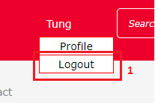 **5.4.1.3. Logout**

**Buttons/Hyperlinks**

|  |  |  |  |  |
| --- | --- | --- | --- | --- |
| **No** | **Function** | **Description** | **Validation** | **Outcome** |
| 1 | Logout | Logout from system, remove session | N/A | Homepage is shown |

**5.4.2. Mobile application**

**5.5. Administrator**

**5.5.1. Web application**

**5.5.1.1. Create model**

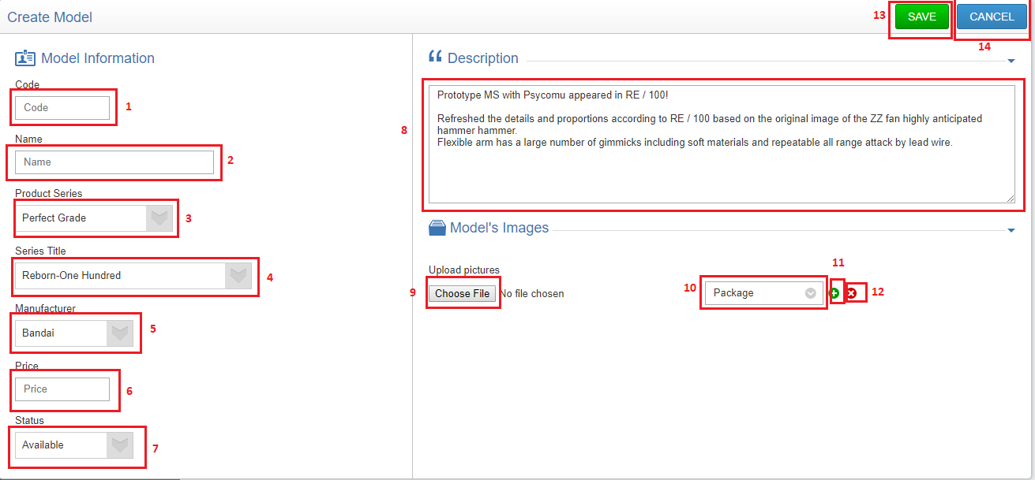

**Fields**

|  |  |  |  |  |  |  |  |
| --- | --- | --- | --- | --- | --- | --- | --- |
| **No** | **Field Name** | **Description** | **Read only** | **Mandatory** | **Control Type** | **Data Type** | **Length** |
| 1 | Code | Model’s code | No | Yes | Text input | String | <= 50 |
| 2 | Name | Model’s name | No | Yes | Text input | String | <= 50 |
| 3 | Product Series | Model’s product series | No | Yes | Dropdown list | String | N/A |
| 4 | Series Title | Model’s series title | No | Yes | Dropdown list | String | N/A |
| 5 | Manufacturer | Model’s manufacturer | No | Yes | Dropdown list | String | N/A |
| 6 | Price | Model’s price | No | No | Text input | String | <= 20 |
| 7 | Status | Model’s status | No | Yes | Dropdown list | String | N/A |
| 8 | Description | Model’s description | No | No | Text input | String | <= 350 |
| 10 | Type of image | Type of image | No | Yes | Dropdown list | String | <= 50 |

**Buttons/Hyperlinks**

|  |  |  |  |  |
| --- | --- | --- | --- | --- |
| **No** | **Function** | **Description** | **Validation** | **Outcome** |
| 9 | Choose image | Choose model’s image | Check valid type of file image | Image name is shown next by |
| 11 | Add more images | System displays 1 new row with the following lables and fields in a horizontal line:   * Import image: input type file * Image type: dropdown list * “+”: button * “-”: button | N/A | New row with the following lables and fields in a horizontal line:   * Import image: input type file * Image type: dropdown list * “+”: button * “-”: button |
| 12 | Remove image | System removes the selected rows, includes:   * Import image: input type file * Image type: dropdown list * “+”: button | N/A | System removes the selected rows, includes:   * Import image: input type file * Image type: dropdown list * “+”: button |
| 13 | Save | Send create model command | All required fields must be input  Invalid format of code  Duplicate model’s code  Length of fields’s value must be in range | Success: model information is saved to database and display model detail page  Fail: show error message |
| 14 | Cancel | Cancel creating model | N/A | Search model page is displayed |

**5.5.1.1. Edit model**

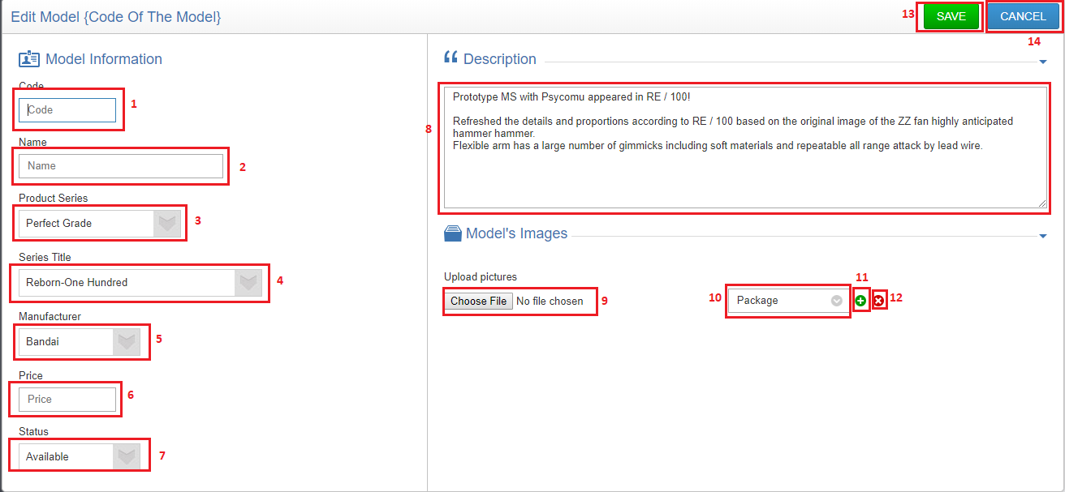

**Fields**

|  |  |  |  |  |  |  |  |
| --- | --- | --- | --- | --- | --- | --- | --- |
| **No** | **Field Name** | **Description** | **Read only** | **Mandatory** | **Control Type** | **Data Type** | **Length** |
| 1 | Code | Model’s code | No | Yes | Text input | String | <= 50 |
| 2 | Name | Model’s name | No | Yes | Text input | String | <= 50 |
| 3 | Product Series | Model’s product series | No | Yes | Dropdown list | String | N/A |
| 4 | Series Title | Model’s series title | No | Yes | Dropdown list | String | N/A |
| 5 | Manufacturer | Model’s manufacturer | No | Yes | Dropdown list | String | N/A |
| 6 | Price | Model’s price | No | No | Text input | String | <= 20 |
| 7 | Status | Model’s status | No | Yes | Dropdown list | String | N/A |
| 8 | Description | Model’s description | No | No | Text input | String | <= 350 |
| 10 | Type of image | Type of image | No | Yes | Dropdown list | String | <= 50 |

**Buttons/Hyperlinks**

|  |  |  |  |  |
| --- | --- | --- | --- | --- |
| **No** | **Function** | **Description** | **Validation** | **Outcome** |
| 9 | Choose image | Choose model’s image | Check valid type of file image | Image name is shown next by |
| 11 | Add more images | System displays 1 new row with the following lables and fields in a horizontal line:   * Import image: input type file * Image type: dropdown list * “+”: button * “-”: button | N/A | New row with the following lables and fields in a horizontal line:   * Import image: input type file * Image type: dropdown list * “+”: button * “-”: button |
| 12 | Remove image | System removes the selected rows, includes:   * Import image: input type file * Image type: dropdown list * “+”: button | N/A | System removes the selected rows, includes:   * Import image: input type file * Image type: dropdown list * “+”: button |
| 13 | Save | Send edit model command | All required fields must be input  Invalid format of code  Duplicate model’s code  Length of fields’s value must be in range | Success: model information is saved to database and display model detail page  Fail: show error message |
| 14 | Cancel | Cancel creating model | N/A | Search model page is displayed |

**5.5.1.3. Delete model**

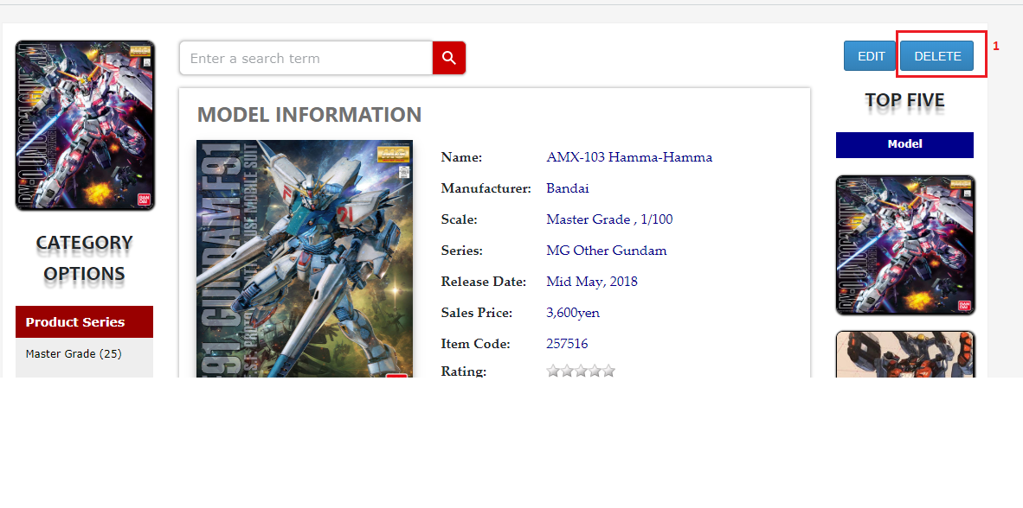

**Buttons/Hyperlinks**

|  |  |  |  |  |
| --- | --- | --- | --- | --- |
| **No** | **Function** | **Description** | **Validation** | **Outcome** |
| 1 | Delete model | Send delete model command | N/A | The selected model is delete and search model page is shown |

**5.5.1.4. Search account**

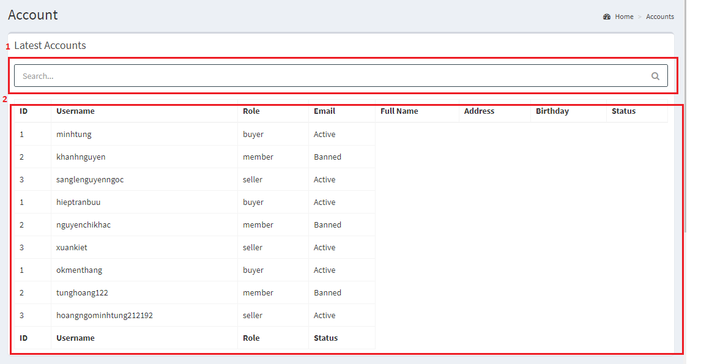

**Fields**

|  |  |  |  |  |  |  |  |
| --- | --- | --- | --- | --- | --- | --- | --- |
| **No** | **Field Name** | **Description** | **Read only** | **Mandatory** | **Control Type** | **Data Type** | **Length** |
| 1 | Search field | Search accounts | No | No | Text input | String | N/A |
| 2 | Account information | Account’s information | No | Yes | N/A | String | N/a |

**5.5.1.5. Ban/unban/edit account**

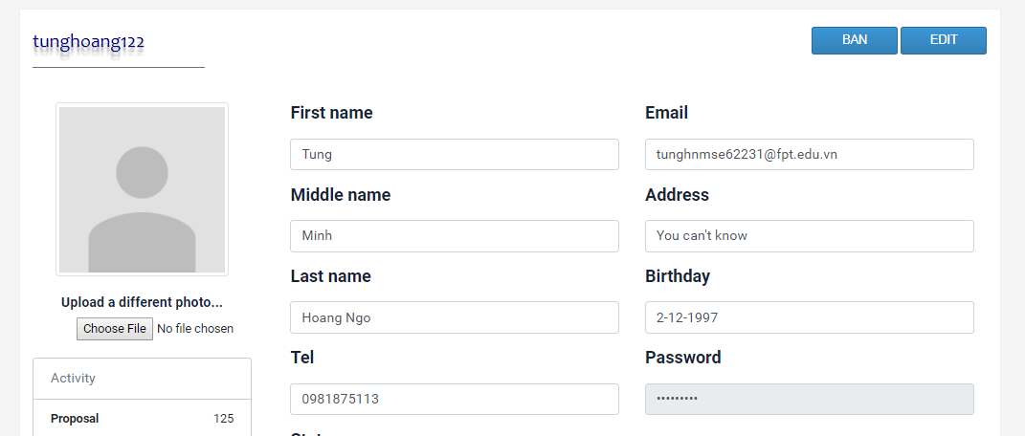

**5.5.2. Mobile application**

**6. Database Design**

**6.1. Entity Relationship Diagram (ERD)**

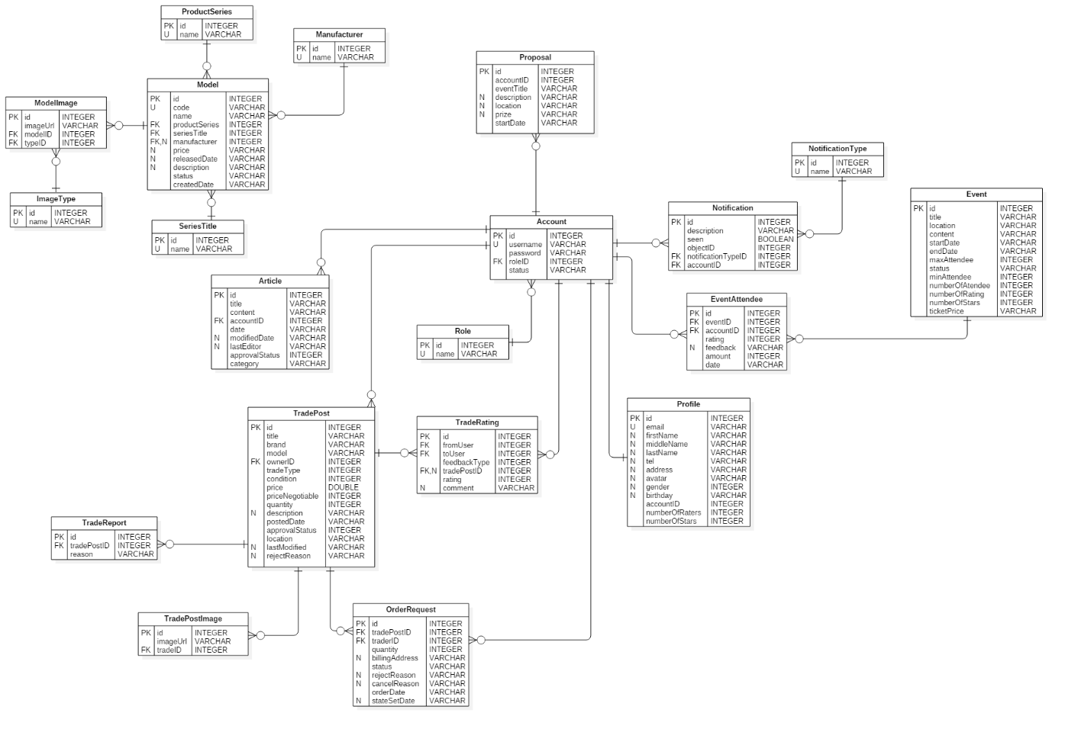

**6.2. Data Dictionary**

|  |  |
| --- | --- |
| **Entity Data Dictionary** | |
| **Entity name** | **Description** |
| Model | Contain model information |
| SeriesTitle | Contain series title information, this is a type of model’s category |
| ProductSeries | Contain product series information, this is a type of model’s category |
| Manufacturer | Contain model’s manufacturer information |
| ModelImage | Contain model’s images |
| ImageType | Contain model’s image type |
| Article | Contain article information which is posted by authenticated users |
| Proposal | Contain proposal information which is posted by members |
| Account | Contain account information |
| Profile | Contain user’s profile information |
| Role | Contain role information |
| Event | Contain event information, which is created by administrator |
| EventAttendee | Contain information about event’s attendee, we also use this table to contain user’s evaluation about the events |
| Notification | Contain notification information |
| NotificationType | Contain types of notification |
| TradePost | Contain trade post information, which is created by buyer/seller |
| TradeRating | Contain user’s evaluation about the exchange |
| TradePostImage | Contain trade post’s images |
| TradeReport | Contain information about user’s report on exchange |
| OrderRequest | Contain member’s order request to trade posts |

**7. Algorithms**